Activity | Timeline | Target Group | Description of Activity
Hispanic Serving Institution 3-year Strategic Plan  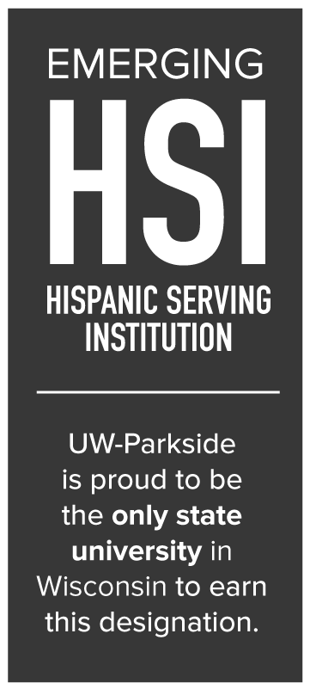 | 2019-2022 | Current and future Hispanic students | Objectives:  Provide on-going support to Hispanic students once they matriculate to UWP.  - Create a curricular and co-curricular approach that allows diverse students to more fully explore and learn about issues and programs of study that are important to them.  - Establish specific pathways relevant to the needs of the Hispanic population.  - Centralize, expand, and target academic and co- curricular Hispanic student development resources.  - Balance enrollment initiatives with persistence and degree completion.  - Help Hispanic students afford college.  Increase engagement with the Hispanic community in southeastern Wisconsin.  - Increase visibility and reputation as an emerging HSI to our communities.  - Increase focus on outreach and recruitment functions aimed at Hispanic youth and their families.  Enhance our identity as a diverse and inclusive campus community that is committed to fostering HSI designation.  - Create a campus culture where all faculty and staff are aware of, and dedicated to, becoming an HSI.  - Increase the number of Hispanic faculty and staff.  - Develop strategic partnerships with Hispanic organizations and other HSI’s or emerging HSI’s for knowledge-sharing and program development to better support Hispanic students.
Emerging Hispanic Serving Institution Website | Current and ongoing | UWP students, faculty, staff, and community members | 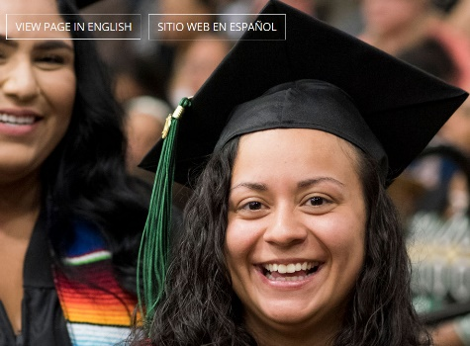  The HSI website is designed to be a common landing page connecting all events, resources, information, and bilingual assistance to students and families. In Spring 2020, the percentage of Hispanic students was 17.7%.
The HSI Network of Wisconsin (HIS-NOW) | Current and ongoing | UWP HSI Steering Committee, and Administration | 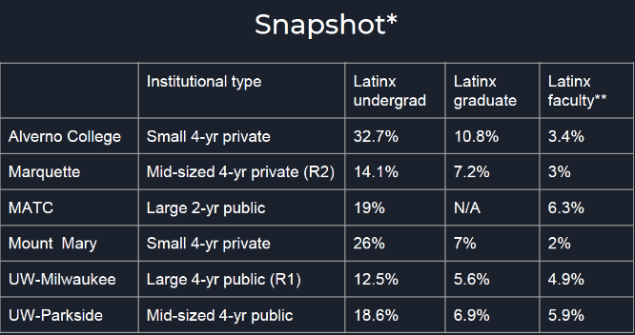  UW-Parkside is a member of the HSI Network of Wisconsin (HSI-NOW) which is a coalition of leaders from higher educational institutions in southeast Wisconsin that have obtained or are working toward the federal designation of Hispanic-Serving Institution (HSI) and are committed to attracting, supporting, retaining, and graduating underrepresented students. Other members of HIS-NOW are Alverno College, Marquette University, Milwaukee Area Technical College, Mount Mary College, and UW-Milwaukee.
Parkside Presente! | Current and ongoing | UWP students and the Kenosha and Racine County Hispanic community | 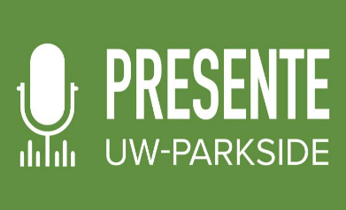  A podcast created in May 2020 to inform and update our Spanish speaking students and community during the pandemic. The podcast shares campus updates, student experiences, faculty and local community organization interviews, highlights of the efforts being made by local public service agencies during the pandemic.  There have been 12 podcasts released to date, and the first having been the most listened to on Parkside Today.
Universidad para Padres | Current and ongoing | Hispanic parents in the Kenosha community | 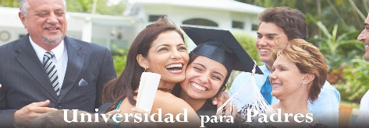  Information sessions designed for Hispanic parents on academic topics such as: planning for college, scholarship opportunities, and career pathways through higher education. Sessions were held face-to-face, but, given the Safer-at-Home order and social distancing, sessions have transitioned online.  Universidad para Padres has served over 25 families to date.
Descubre Parkside | Current and ongoing | Middle school students and families in SE Wisconsin | 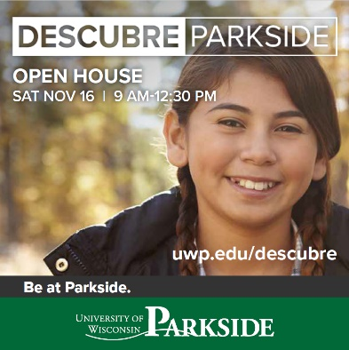  Since 2016, CSSPS has partnered with heavily populated dual-language schools to foster the idea that college is an achievable option for any student. CSSPS partnered with middle schools to bring interested students and their families in to visit UWP in a Spanish language only event. We provided transportation, childcare, and lunch while parents/guardians and students participated in learning sessions designed to answer their questions about college. Visitors were given campus tours and the opportunity to question a student panel regarding life on campus, classes, housing, and the student experience.  In 2019, we had 200 participants. This year we will offer Descubre Parkside as an online experience. e.g. virtual tours, entirely in Spanish.
Yo Soy Parkside | Current and ongoing | Prospective UWP students in SE Wisconsin and northern Illinois | Yo Soy Parkside is an annual visit day for prospective Spanish-speaking students and their families to meet current students and faculty. Activities during the event include: a keynote speaker, experiential workshops, engage-with-a-student panel, and receive a campus tour.
The College of Social Sciences and Professional Studies (CSSPS) Website in Spanish | Current and ongoing | UWP students, prospective students, and the community | The College of Social Sciences and Professional Studies (CSSPS) recognizes the importance of serving all students at UWP. The CSSPS Strategic Plan includes support for UWP seeking HSI status and, as a result, offers the College’s full website in Spanish.  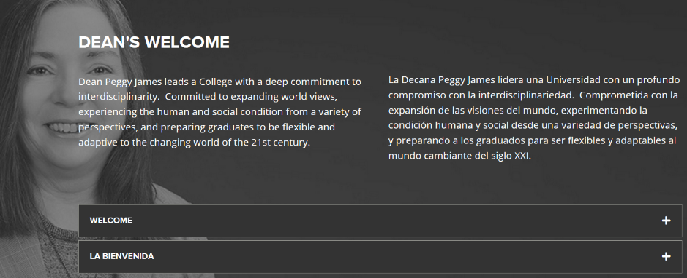
Parkside Access to College Credits (PACC) | Current and ongoing | High school students in SE Wisconsin | 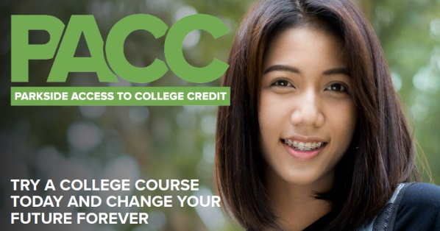  The Parkside Access to College Credit Program (PACC) is a concurrent enrollment program which offers high school students the opportunity to earn college and high school credit simultaneously. The PACC program’s goal is to allow all students access to college addressing the equity gap seen in dual enrollment programs nationwide. Barriers to participation by underrepresented minorities (URM) have been minimized.  In 2019-2020, 42% of students enrolled in PACC were underrepresented minorities. Hispanic students accounted for 46% of the total URM students.
“We’re Here for You” en español | May 3-8 & 11-15, 2020; Fall 2020 | UW-Parkside Hispanic students | 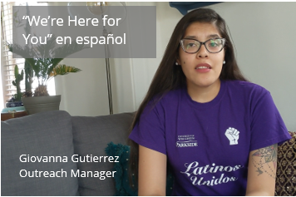  Recorded video messages directed to our Hispanic students and their families, providing general information regarding academics and financial assistance during the pandemic in spring 2020. Videos were posted to the university COVID update webpages, and now can be found on Vimeo.  Similar messaging is planned for the fall semester.
The Election Experience recruitment/ enrollment | May 1 – Nov 1, 2020 | UWP students and community (all under represented populations) | 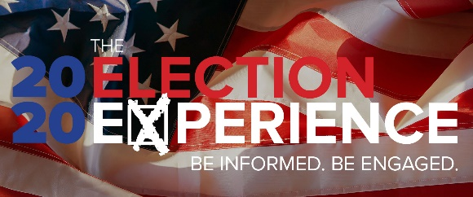  Fall 2020 education and engagement for Hispanics, African American, and Asian Americans around the presidential election. This semester’s Election Experience will ask every student to register, vote, and engage with important issues. Events include a partnership with the Kenosha Coalition for Dismantling Racism to present on vote suppression, as well as a workshop on depolarizing political attitudes within and across groups.
Voter Registration | Jul 1-Oct 15, 2020 | UWP students and community (all underrepresented populations) | Fall semester mobilization for Hispanics, African American, and Asian Americans. We have 3 student interns this year to mobilize the vote, partnering with Latinos Unidos, LULAC, and BSU.
Hispanic Association of Colleges and Universities (HACU)  Fifth PreK-12/Higher Education  Collaboration Symposium | Oct 19, 2019 | National Symposium, network building with other HSI connections | 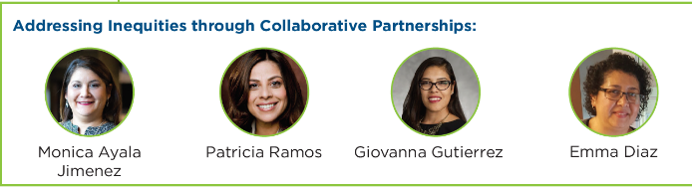  Giovanna Gutierrez, CSSPS Operations and Program Manager, was a presenter for the Addressing Inequalities through Collaborative Partnerships session at HACU. The Symposium focused on high impact collaborative practices implemented between colleges, universities, school districts and the community that have led to systemic change.
18th Latino Higher Education Leadership Institute (HACU)  Presidents Panel | Oct 8, 2019 | National Institute, network building with other HSI connections | Chancellor Debbie Ford represented UW-Parkside on the Presidents Panel as the only emerging Hispanic Serving Institution in the Wisconsin public system at the 18th Latino Higher Education Leadership Institute.
La Voz Del Pueblo  (The Voice of the People) | Oct 8, 2019 | UW-Parkside faculty, staff, students, and community members from SE Wisconsin | 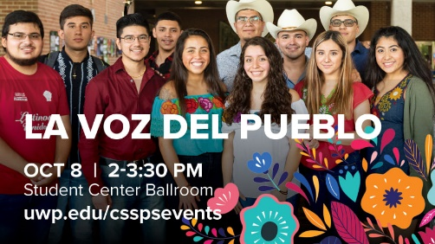  UW-Parkside faculty, staff, students, and community members came together in an effort to chart the continuing mission of UW-Parkside to serve underrepresented groups. Specific topics discussed were increasing the aid, support, and access to quality higher education for students of Hispanic descent—particularly first-generation and low-income students.  70 students and staff participated in this open dialogue.
Hispanic Heritage Month Celebration  3rd Annual Festejo de lideres  (Celebration of Leaders) | Sep 22, 2019 | Hispanic Community & Community Leaders | 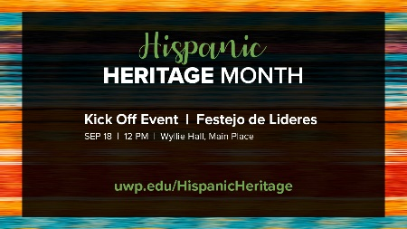  Festejo de lideres kicked off Hispanic Heritage Month. The College of Social Sciences and Professional Studies and the College of Arts and Humanities welcomed the 2020 UW-Parkside Hispanic Leadership award recipients. UW-Parkside and local communities are shaped by leaders who speak up, take action, and rally others to support a cause.  50 people were present to celebrate the Hispanic Leadership awardees.
Mexican Fiesta | Aug 2019 | Hispanic Community | UW-Parkside was a sponsor of Mexican Fiesta held in Milwaukee, WI. This festival welcomes thousands of people every year. Our participation and efforts to build community is part of the university’s mission to become a Hispanic Serving Institution.
Raices | FUTURE  Beginning Sep 1, 2020 | Students and Community | A digital collection of stories, portraits, and images that touch on the impact of our cultural history across time. This project is part of our Hispanic Heritage celebration and we hope the collection grows over time. Entries can include: historical anecdotes, images, family portraits, and heirlooms  Site unveiling at the end of Hispanic Heritage 2020 (Mid-October)
Uncovering an Alternative Historical Narrative: A Hispanic American Perspective | FUTURE  July 2021 | SE Wisconsin high school students and social studies teachers | 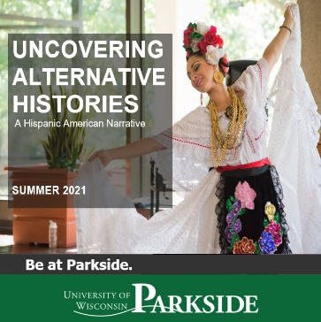  The Uncovering an Alternative Historical Narrative; Diverse Contributions to American History and Civics program is a U.S. Department of Education grant-funded program that explores alternative narratives of groups that have experienced and participated in the making of history, but whose narratives have been mediated, appropriated, or erased. The program will focus on the Hispanic American narrative in Summer 2021 with traditional classroom learning and place-based learning in Chicago, IL and El Paso, TX. Participants will have the opportunity to cross the US/Mexico border on the Paso del Norte Bridge.  We anticipate 100 high school students and 50 high school teachers will participate.

