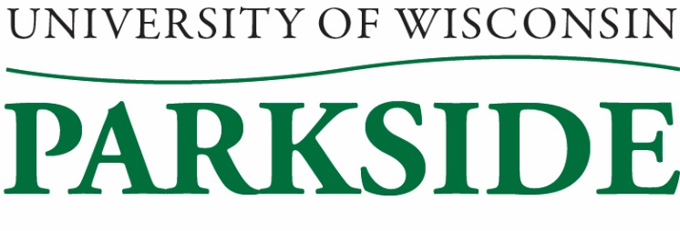

University Staff Committee - Meeting Minutes
August 10, 2023 / 1:00 PM – 2:00 pm
Galbraith room & Teams

Members Present: Sherry Craig, Lisa Crumble, Alex Gray, Jean Hrpcek, Carol Kinsley, Michele Oakes-Cisler, April Puryear, Heather Spencer
Members Absent: Loki Lott
Guest: Sheronda Glass

Call to Order: 1:01 pm by Carol Kinsley

Meeting Minutes Approval for July 13, 2023
Minutes approved unanimously.

Campus/System Updates (Sheronda)
ATP
ATP rapidly getting ready to train staff in system. Currently in the process mapping security roles for everyone. Everything BPLogix related will be in Workday, which will drastically streamline a lot of HR processes. Derek Fye has been adding ATP updates in Wednesday Weekly and ATP’s site itself has frequent updates. The finance and IT side is not progressing as fast as HR. No push on July launch date.

Payplan
Legislation approved 4% payplan increase effective July 2023, but needs to go to the JCOER for final approval. It is on the August agenda, but will be pushed to October if not acted on. On target to be approved.

Budget/All Campuses
We’re not quite at pre-pandemic levels of enrollment despite increasing. Looking at a $5-5.8 mil deficit with only $2.1mil in reserves. Board of Regents/President Rothman has said we need to be solvent by 2028. Budget team has been meeting about next steps and will be putting out info next week. No plans on consolidation of campuses. Furloughs were discussed as potentially being on the table.
UWSystem has hired a financial consulting firm that will come out to each campus to look at our finances, starting in November.
There are UWSystem funds meant for campus innovation, but they’re under strict guidelines. Rob is heading a group to see what we can do to get some of that money.

Ask Me Tables (April)
Ask Me tables are set to be up across campus on Sept 6th and 7th from 7:45a-12p. April is working with the Ranger Welcome Committee to get volunteers. Volunteers don’t necessarily need to be tied to a table to help; idea is to have volunteers in Ask Me shirts all around campus.

Committee Reports
Regent’s Excellence Awards: No announcement on university staff winners yet.

US Scholarship
Carol Kinsley found a report from Advancement about this scholarship and spoke with Hannah Wallisch about it. Hannah is attending next month’s meeting to discuss this endowed scholarship in more detail with us. The last time it was given out was in 2021-22 for about $900. We should consider promoting it amongst Parkside university staff as it seems it is not well known.

New Business
No new business.

Adjournment:
Motion to adjourn by Carol Kinsley and seconded by Heather Spencer.
Meeting adjourned: 2:01 pm

Minutes submitted by: Alex Gray

