Instructions for Completing Performance Evaluation

Section 1: Goals

Employee should list goals for the review period. After discussion with manager, manager will select “met goals or did not meet goals for performance.”

Section 2: Performance Competencies

Employee completes “self-evaluation” by clicking “Choose a rating.” For ratings of 4, 1 or 0, employee must add a comment to justify rating. This is repeated for all competency areas.

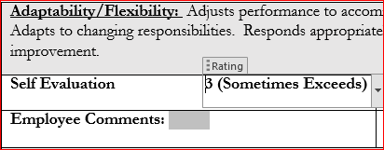

Manager completes “Supervisor” section by clicking “Choose a rating.” For ratings of 4, 1 or 0, manager must add a comment to justify rating. In “Rating #” area, manager enters score given. This is repeated for all competency areas.

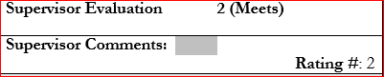

Section 3: Department Specific Competencies

This section should be completed if you have additional department specific competencies that you would like to have included in the employee’s performance evaluation. The 3 available fields are left blank for you to enter the specific competencies for which you would like to measure.

Section 4: Compliance, Training and Development

This section should be completed to document all mandatory training and development requirements for the evaluation period. Managers and employees may also list any additional training and development opportunities completed during the evaluation period.

Section 5: Overall Rating and Signatures

Manager completes this section by using the following formula:

Sum of ratings from each competency areas divided by total number of competencies = Final Rating
Example ____/12 (13 for Mgr.) = _________.

An overall rating of “2” or higher is deemed to have met expectations. A rating lower than “2” is deemed not
to have met expectations.

