

**New Learner Registration**

Step 1: Create an account



Step 1: Select your institution and check the boxes to continue to create an account

Search for and select University of Wisconsin-Parkside from the drop-down menu

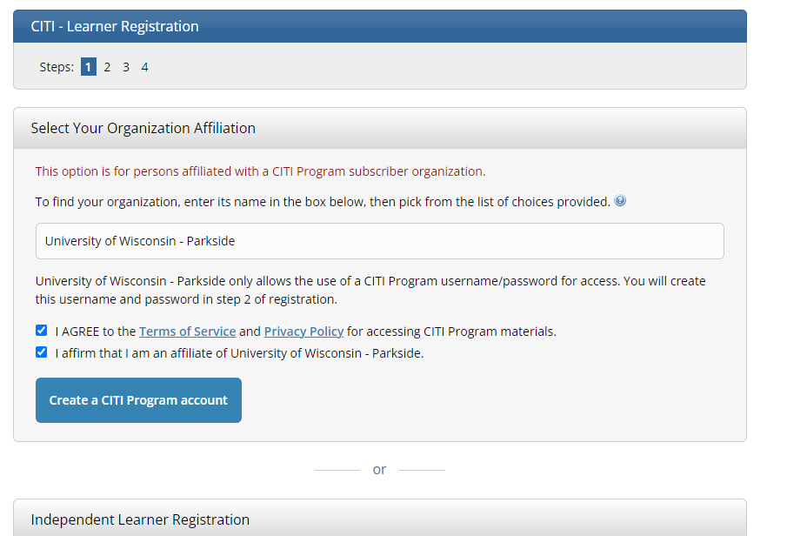

Step 2: Provide your name and institutional email address, continue to step 3

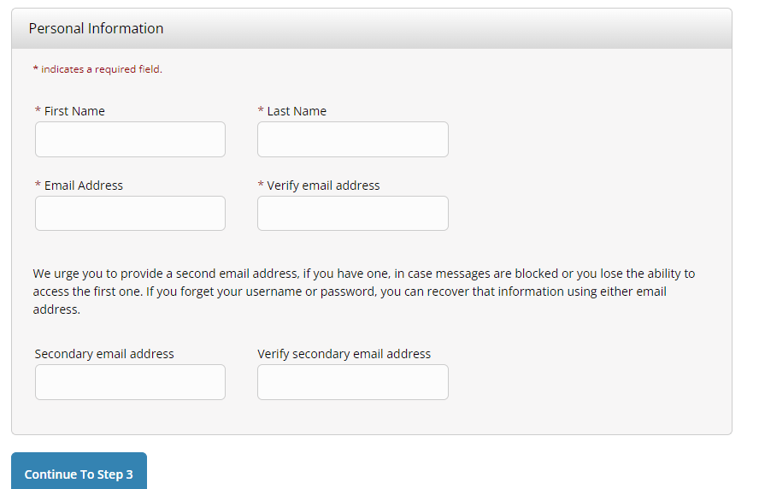

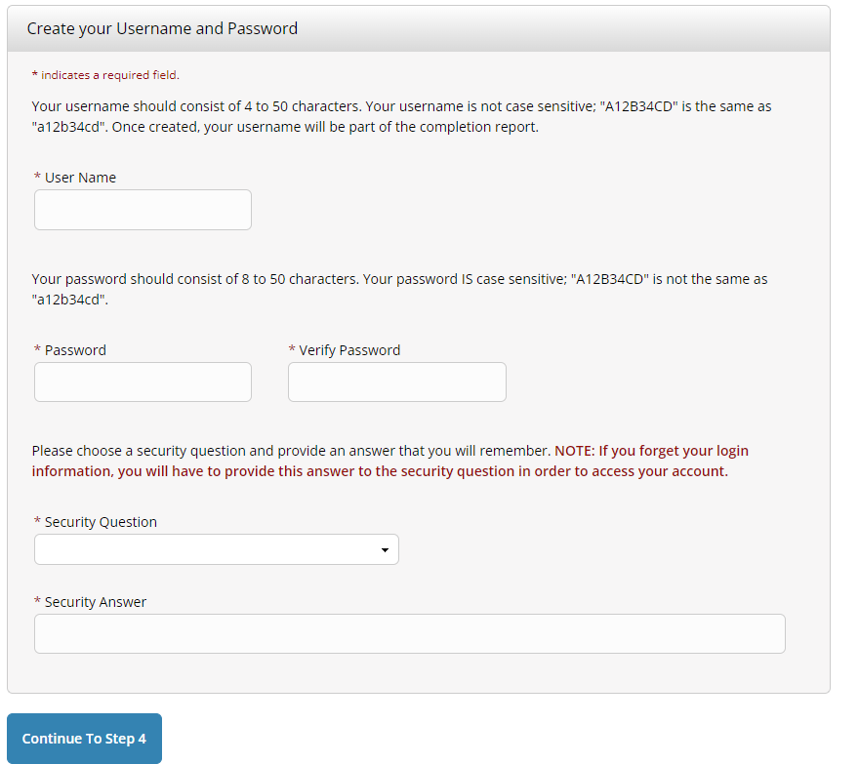

Step 3: Create your user name and password, complete the security question to continue to step 4

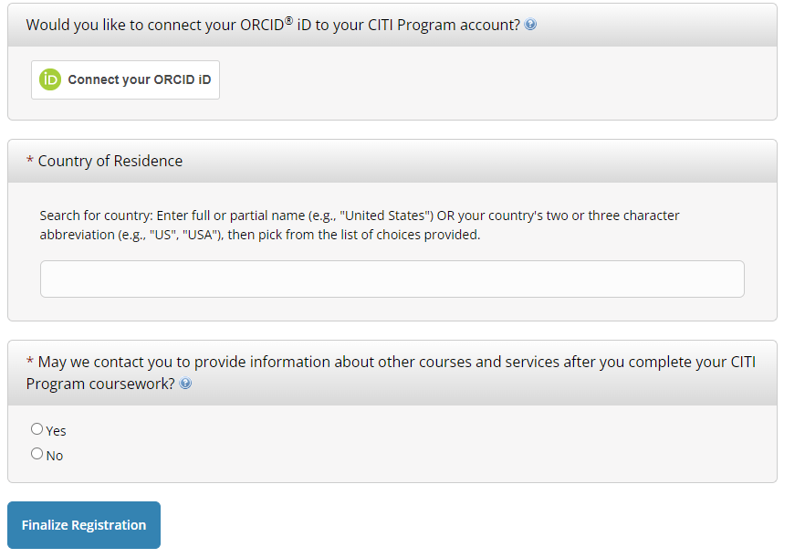

Step 4: Complete the requested information and finalize registration

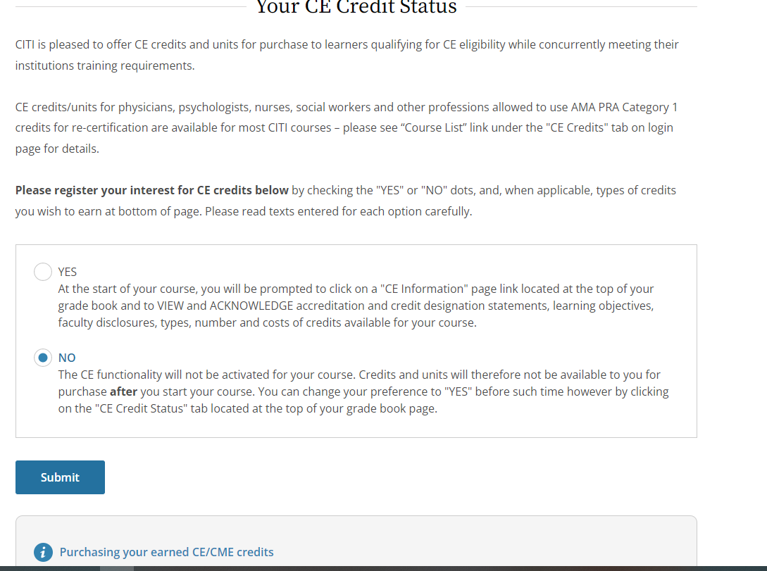

Choose your CE credit preference – PLEASE NOTE ANY CHARGES ASSOCIATED WITH CE CREDITS IS PAID BY THE USER AND NOT THE UNIVERSITY

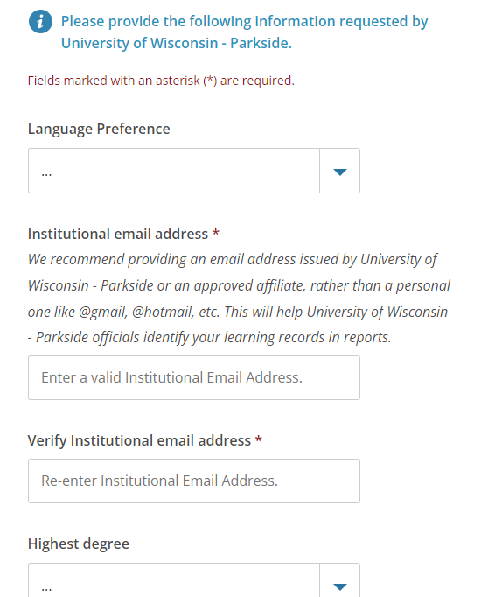

Complete the information requested

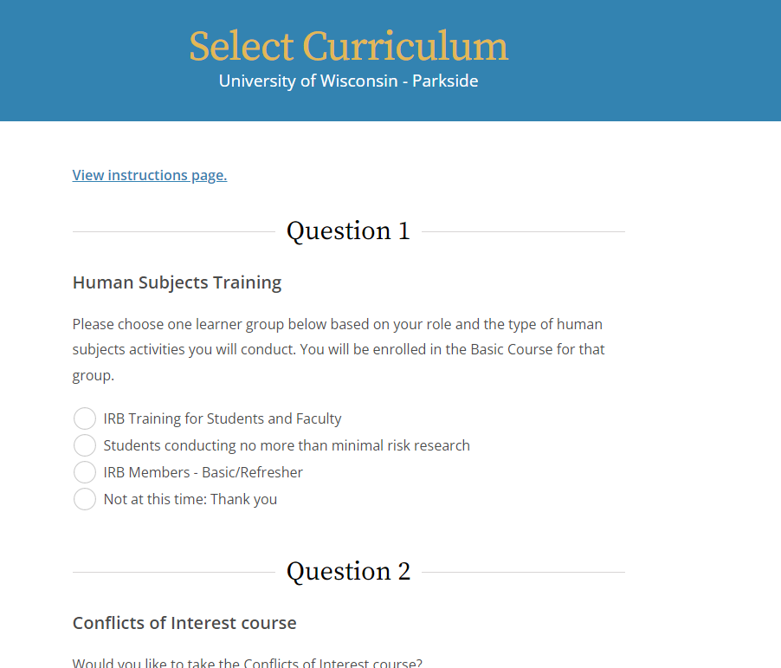

Answer the questions to select the curriculum that will be assigned to you

You are now enrolled and can begin your courses. If you have any questions please email [IRB@uwp.edu](mailto:IRB@uwp.edu) and we will do what we can to help you out.