Overview

Report Overview from the Committee on Creative Practices

Chairs: Jake Bray and Lesley Walker
Members: Alvaro Garcia, Misti Bradford, Jim Crowley, Tom Berenz, Chris Barker, and Chris Hudspeth

Following the University’s tandem goals of delivering a high-quality educational experience to our students during fall 2020 and our commitment to safety and peace of mind during the Coronavirus pandemic, our committee identified 5 categories and subsequent recommendations for each to achieve these objectives.

In addition to the overview of our recommendations, we have also attached more granular data on which our recommendations are based. We put these in an appendix: A) Space analysis of the Rita B) Compilation of recommendations from various national performing and visual arts associations C) Detailed teaching plans from each department in CAH.

Teaching
The visual and performing arts faculty agreed that some form of F2F instruction was necessary for a successful semester. Music, Theatre, and Art each studied their respective fall semesters and provided recommendations for each fall 2020 course. (The detailed description from each department can be found in appendix C).

- F2F Those courses that require visual, tactile, auditory instruction and that are extremely difficult to deliver entirely online should remain F2F. By in large, class sizes will be no more than 12 and often fewer students in any one space at a time. (In very limited cases, a larger group may come together but strict distancing and hygiene MUST be observed. For this to happen, the instructor should submit a safety plan to the Dean’s office prior to any larger gatherings). The following safety precautions need to be followed:
  - Masks must be worn
  - Hand sanitizing at the beginning of each class
  - Students should wipe down any surfaces that will be used by them. Classes will start 5 minutes later than in the schedule.
  - Social distancing must be created through classroom redesign and clear indications about where each student should be positioned and remain throughout the class period.
  - Where necessary due to lab or studio size, classes will be divided into halves or thirds to ensure adequate social distancing. For example: a class of 20 that meets for 6 studio hours a week would be divided into 10 (an A and a B group); the smaller groups would meet for more individualized instruction for 3 hours a week.
  - Classes should end with sufficient time to avoid egress bottle necks; it will be important to maintain social distancing as students leave and enter any space.
  - Students will have monitored access to art studios, lab spaces, and practice rooms outside of regular class time. To ensure necessary hygiene and social distancing practices, it is recommended that an online, sign-up schedule be developed.

- Hybrid Courses will follow the same guidelines as the above.
- Online Due to the large enrollments in most of CAH’s visual and performing arts General Education courses such as Theater, Music, and Art Appreciation, these courses will go online for fall 2020.

Academic Performances

- Music The music department will not offer any “live” performances during fall 2020. Instead, “concerts” will be either live-streamed or a recording produced as a cap stone experience for the students. There are discussions of ensembles working together to produce high-quality recordings.
- Theatre Theatre intends to move forward with modified productions and an acute awareness of health protocols for all members of the cast and crew. There will be no audiences but, as with music, the department will experiment with live-streaming, Zoom staged readings, and recorded material. (Details are in appendix C5).

Community

- We recommend against filling our hall and stages with community players and/or audiences, given the risk of large gatherings. That is to say: no community band, choir, or orchestra. This is a difficult and painful decision for us, especially given the long histories of these ensembles, but we believe that it is in the best interest of Parkside and our community. Similarly, we will not host the Noon Concert Series and other visiting musicians. As mentioned above, our student performances will not be opened to community audiences.
- We will, however, consider very limited access to our facilities by community members for educational and artistic purposes. These exceptions must be approved the Dean’s office.

Safety

- It will be imperative that all classrooms, studios, stages, and labs be furnished with the necessary sanitizing products. We recommend hand and surface sanitizing stations in each instructional space that students may use themselves. These will need to be replenished daily.
- Faculty who teach F2F or Hybrid will need to oversee the cleaning of their spaces by students; ensure that students socially distance and wear masks during the class period; and manage the comings and goings of students to avoid congregating.
- We recommend that an analysis of performance spaces be undertaken to ensure that rooms are not overused; that they have a chance to “rest” in order to avoid lingering aerosol particles.
- We recommend that instructors include the University’s Code of Conduct on their syllabi to spell out student responsibilities in this new environment.

Technology We recommend the aggressive use of digital technologies that will allow UWP to have a robust virtual presence not only in the visual and performing arts but for the campus as a whole—Science Night, the Election Experience, and various sporting events, for example.

- Immediate acquisition of the live-streaming and live capture equipment—camera, mics, switchers and so forth—that will allow us to do this type of work
- Assembling a team of experts from CAH, Athletics, Campus Technology Services, and Creative Services to work together to make these technologies broadly available across campus.
- Develop independent study classes and/or internship for students to learn these useful and highly valued skills in collaboration with Music, Theatre, and Digital Media and Production (DMAP).

NB: Work to identify and provide the Campus community with an opportunity to use the large spaces in the Rita at times that do not impact CAH’s educational needs.

Appendix A.1
C.A.H. Social Distancing Room Analysis Overview

C.A.H. Social Distancing Room Analysis Summary
MUSIC
Room Number | Total Capacity with Social Distancing | Notes
D164 | 12 (6 singing) | without risers
D184 | 22 | Accounts for typical room use and equipment
D179C | 7 | Accounts for typical room use and equipment
L187 | 5 | not accounting for equipment
L167 | 2
L169 | 2
L165 | 4 | Number and size of workstations limits capacity to 4
L163 | 2 | Number and size of workstations limits capacity
L164 | 12 | Stations have to be moved, but there is enough space to do so, extra furniture would need to be removed
THEATRE
Room Number | Total Capacity with Social Distancing | Notes
D115 | 4 | Limited by workstations
D116 | 12 | Studio B
D119 | 13 | Costume shop - Limited by workstations
D120 | 2
D132 | 15 | Studio A
ART
Room Number | Total Capacity with Social Distancing | Notes
L123 | 23 | Pending remodel
L124 | 31
L132 | 23 | will fit all current keyboard stations if whole room is utilized.
L127 | 16 | Pending remodel
L121 | 29 | Pending remodel
L117 | 20 | Pending remodel
D101 | 12
D102 | 27 | Contact Art department/K. Bartel about workstation layout details
D102A | 11 | Contact Art department/K. Bartel about workstation layout details
D106 | 36 | Pending equipment use
D109 | 26 | Pending equipment use
D105 | 10
D113 | 8 | Pending equipment use
PUBLIC/PERFORMANCE SPACES
Room Number | Total Capacity with Social Distancing | Notes
Bedford Stage | 22 | Bedford Stage (risers folded)
Bedford Seats 1st floor | 28 | seats in house
Blackbox (whole space) | 69 | Would require removal and storage of risers
Blackbox (stage) | 22
D129 (Fine Arts Gallery) | - | Availability TBD
Mathis Gallery | - | Availability TBD
Mainstage Theatre Stage | - | Varies based on production
Mainstage Theatre House | 68
MS Left Balc | 16
MS Right Balc. | 16

C.A.H. Social Distancing Room Analysis Music

MUSIC
Room Number | Dimensions sq ft. | divided by 40 sq ft. | Capacity after furniture/fixed equipment | Total Capacity with Social Distancing | Notes
D164 | 1376 | 34 | 12 | 12 | choir room - Room dimensions listed without risers. 12 people can fit on risers.
D184 | 1487 | 22 |  | 37 | doesn't include stands and instruments 980 sq ft with instruments (27 people)
D179C |  | 0 |  |  | Too much equipment
L187 | 342 | 9 |  |  | not accounting for equipment
L165 |  | 0 | 3 | 3 | Number and size of workstations limits capacity to 3
L163 | 266 | 7 | 4 | 4 | Number and size of workstations limits capacity
L164 | 756 | 19 | 16 | 16 | Stations have to be moved, but there is enough space to do so, extra furniture would need to be removed

C.A.H. Social Distancing Room Analysis Theatre

THEATRE
Room Number | Dimensions sq ft. | divided by 40 sq ft. | Capacity after furniture/fixed equipment | Total Capacity with Social Distancing | Notes
D115 |  |  | 4 | 4 | Limited by workstations
D116 | 816 | 20 | 12 | 12 | Studio B
D117 | 572 |  | 7 | 7
D119 |  |  | 13 | 13 | Costume shop - Limited by workstations
D120 |  |  | 2 | 2
D132 | 980 | 25 | 15 | 15 | Studio A

C.A.H. Social Distancing Room Analysis Art

ART
Room Number | Dimensions sq ft. | divided by 40 sq ft. | Capacity after furniture/fixed equipment | Total Capacity with Social Distancing | Notes
L123 | 928 | 23 |  | 23 | Pending remodel
L124 | 1248 | 31 |  | 31
L132 | 902.52 | 23 |  | 23 | will fit all current keyboard stations if whole room is utilized.
L127 | 648 | 16 |  | 16 | Pending remodel
L121 | 1160 | 29 |  | 29 | Pending remodel
L117 | 795 | 20 |  | 20 | Pending remodel
D101 | 491.36 | 12 |  | 12
D102 | 1096 | 27 |  | 27 | Contact Art department/K. Bartel about workstation layout details
D102A | 441.6 | 11 |  | 11 | Contact Art department/K. Bartel about workstation layout details
D106 | 1443 | 36 |  | 36 | Pending equipment use
D109 | 1026 | 26 |  | 26 | Pending equipment use
D105 | 928 | 23 | 10 | 10
D113 |  |  | 8 | 8 | Pending equipment use

C.A.H. Social Distancing Room Analysis Public/ Performance Spaces.

PUBLIC/PERFORMANCE SPACES
Room Number | Dimensions sq ft. | divided by 40 sq ft. | Capacity after furniture/fixed equipment | Total Capacity with Social Distancing | Notes
Bedford Stage | 786.25 | 22 |  | 22 | Bedford Stage (risers folded)
Bedford Seats 1st floor house |  | 28 |  | 28 | Bedford Seats - Sq. Footage in separate document
Blackbox (whole space) | 2752 | 69 |  | 69 | Would require removal and storage of risers
Blackbox (stage) | 868 | 22 |  | 22
D129 (Fine Arts Gallery) | 2236 | 56 |  |  | Not including ramps and stairs
Mathis Gallery | 864 | 22
Mainstage Theatre Stage
Mainstage Theatre House |  |  |  | 68
MS Left Balc |  |  |  | 16
MS Right Balc. |  |  |  | 16

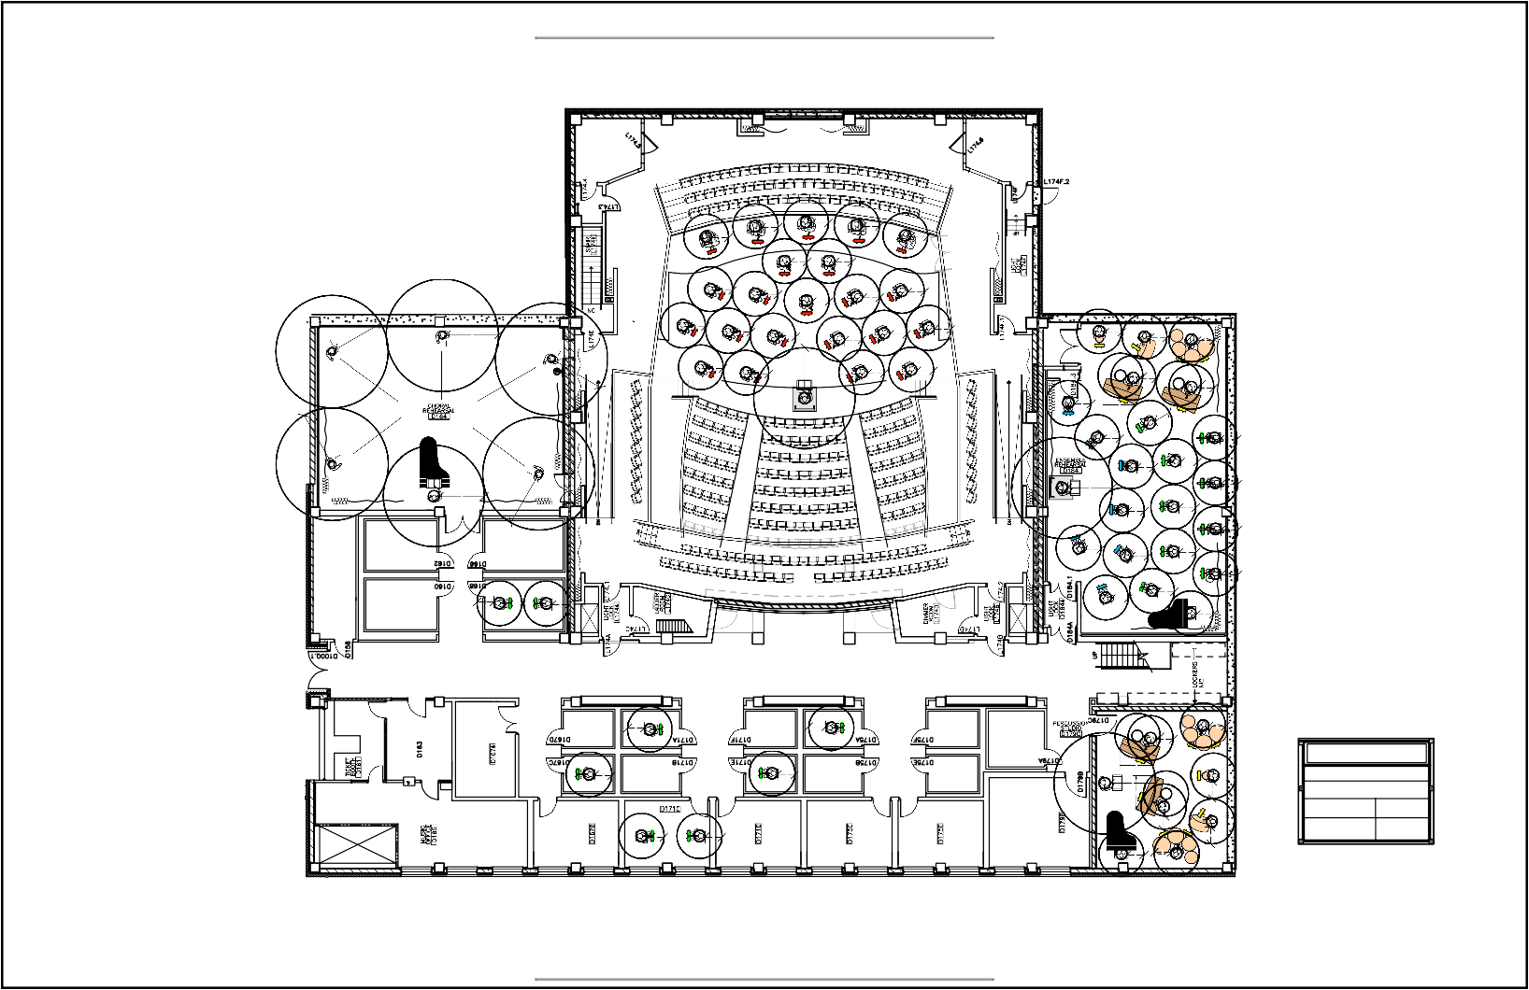

Piano Lab Setup (12) Classroom Setup (15)

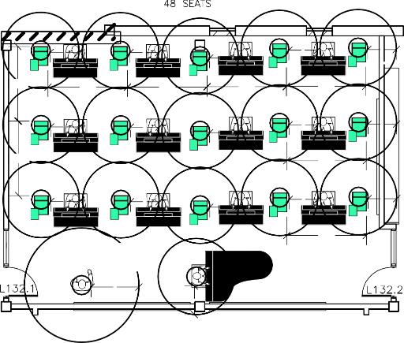
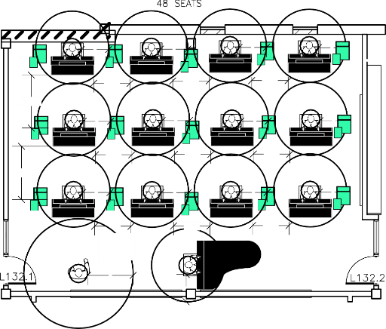
3
3
3
3
3
7'-10"
8'-4"
8'-4"
8'-4"
8'-4"
3
3
3
3
3
7'-10"
8'-4"
3
3
3
3
3
8'-4"
5

desk 4x3
podium
3
3
3
3
4'-0"
4'-0"
4'-0"
5'-10"
3
3
3
3
4'-0"
4'-0"
4'-0"
5'-10"
3
3
3
3
4'-0"
4'-0"
4'-0"
5

desk 4x3
podium

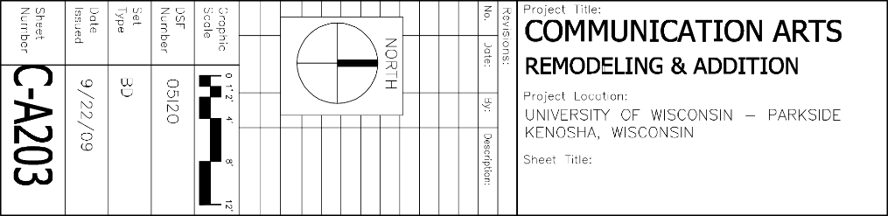
D

UCATIONAL VERSION

S E

RK

WO

OR

CT

VE
