USER GUIDE
Campus Process: PCardholders
Adding documentation to a Closed System PCard Transaction

SFS PCard Transactions
In March 2022, the PCard transactions are in SFS. As a PCardholder, you will receive an email for each transaction. For each transaction, it must be verified and approved within 30 days of the posted date. Remember you will receive an email at day 15 and then daily until the transaction is verified and approved or it will be closed by system.

If you add a business purpose and attachments and verify your transaction, the transaction still needs approval before the 30 days. If you receive notifications that you have outstanding transactions and you have done your part, make sure that you nudge your approver to make sure the transaction is approved before the system closes it.

Approved and Closed by System Transactions
When your transaction is verified and approved by day 30, the transaction is closed by system. These transactions must be in compliance with the Procurement card rules. This means they must have a Business Purpose and the appropriate attachments.

Auditing Closed Transactions
The P-Card manager will audit the PCard transactions. If you receive notifications that you need additional documentation, you will need to access the transaction in SFS.

Accessing Closed Transactions
You will receive a BP Logix notification of your audit closed transactions. In order to see your transactions, you must go to the UWP logins page https://www.uwp.edu/logins/ and choose SFS (E-Reimbursement/ P-Card)

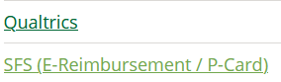

This will take you to the SFS system. You will have to go through SSO. Click on the Reconcile Statement tile. This will take you to the Reconcile Statement page. If you have any current transactions, you will see a list of transactions, possibly in verified, approved, or initial stage. Verified transactions are in your approvers queue. Approved transactions will be gone when paycycle runs and initial status means you have not yet verified them. We are looking for CLOSED transactions. Those are not displayed here. Click on the Search hyperlink in the bottom left.

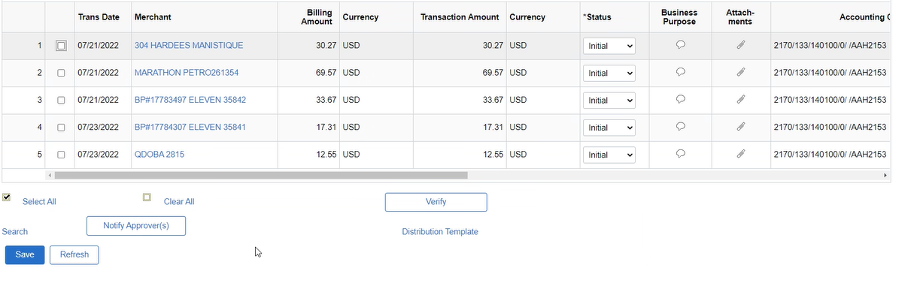
When you click on the hyperlink OR you do not have any current transactions, you will see a search.
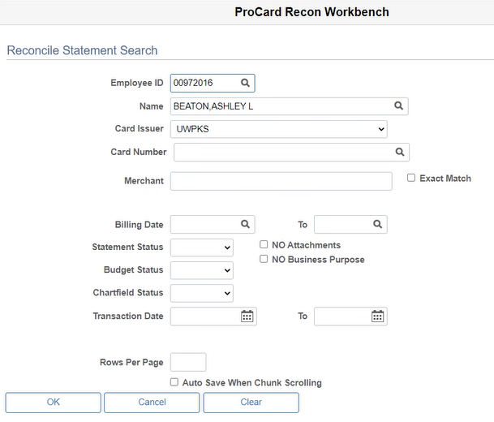

To find the transactions, use the Statement Status. Change the status to Closed. You can add transaction dates, merchants, etc., to limit the information retrieved. The information is in the BP Logix form.
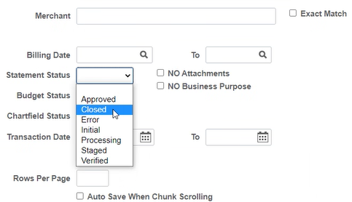

Updating the Business Purpose
When you have the transactions, you can update a business purpose in the same way you would for an open transaction. Use the Business Purpose conversation bubble. The status will be CLOSED for these transactions, not initial.
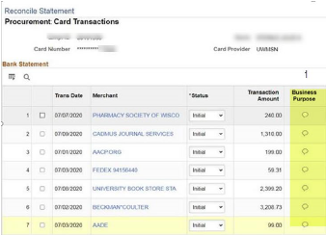

Adding more Attachments
The transaction, as all PCard Transactions, must have an itemized receipt and any other required documentation per procurement rules. You can add the attachments as you would if the transaction were still in the initial stage using the paperclip.

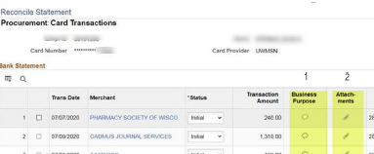

Reallocation
You cannot reallocate the funding on closed transactions. Please work with your department contact to ensure that a journal entry is submitted through COST to reallocate funding.

Approvals
When you have completed the Business Purpose and the Attachments, your approver will need to approve. You cannot use the Notify Approver button as there is no approver on a closed transaction. Because an approver cannot approve the transaction in SFS, they will have to provide something in PDF form and add it to the Attachment. Complete the process to move to the approver step.

You can use the Notify approver button or let them know outside the SFS system through messaging or email.
Or if you purchased something close to Year-End cutoff.
If you don’t have the tile set up yet, follow the instructions to do so.

