INSTRUCTIONS FOR COMPLETING PURCHASE AUTHORIZATION FORM

1 – Date you are preparing the form.
2 – Type of Request; check box to indicate type of transaction.
Purchase Order – Required when pre approval is needed by Purchasing or vendor requests a formal PO.
Confirming – Payment for delegated transaction (attach vendor invoice).
LDO – Transaction placed by department, invoice to follow from vendor.
Cash w/Order – Vendor requires prepayment, include price verification.
Change Order – Request for amendment to an existing order.
3 – Vendor information; UW-P vendor number and name OR vendor name and complete address.
4 – Amount of transaction to be charged to account.
5 – Complete accounting string.
6 – Fiscal year; 2002, 2003 etc.
7 – Vendor contact phone number.
8 – Vendor Fax number.
9 – Referral to second page of authorization if more than three lines of funding are needed.
10 – Person who will be using goods or services and date requested.
11 – Required signatures and dates of approvals.
12 – Line item number; 1, 2, 3, etc.
13 - Indicate quantity desired.
14 – Unit of Measure e.g. Ea, dzn, lb, sq ft, lot, gross, ton, C, M, etc.
15 – Describe what you are ordering including manufacturer, model number, catalog number, etc.
Use this field for comments i.e. “Confirming Fax Order (date) – DO NOT DUPLICATE.
16 – NIGP Code (optional).
17 – Price of one UOM (see #14).
18 – Referral to second page of authorization if additional space is needed for items or comments.
19 – Previous order number for a repeating transaction.
20 – Freight Terms; Dest. (vendor paying for delivery) S/P (University pays), PP&A (vendor pays and adds cost to invoice, I (installed).
21 – Payment Terms, usually Net 30 unless vendor offers discount for prompter payment.
22 – UW-Parkside, UW-Madison, or UWS contract or Bid Number.
23 – UWS waiver number.
24 – Usually State Procurement Manual reference.
25 – State Bulletin Number.
26 – Where Receiving Department will deliver.
27 – Date materials/services are needed.
28 – Shipping instructions to vendor; UPS, Fed EX, hold for pick-up, common carrier, vendor truck, etc.
29 – Number to call for delivery instructions or arrangements.
30 – Vendor remittance instructions.
31 – Check to indicate a service from an individual, sole proprietor, or LLC (taxable income).
32 – Indicate attached is a quotation, invoice, bid specs, ordering information etc.
33 – Name and extension of person completing form.
34 – Attach voided requisition or assign number to form.

RGF 4/4/02

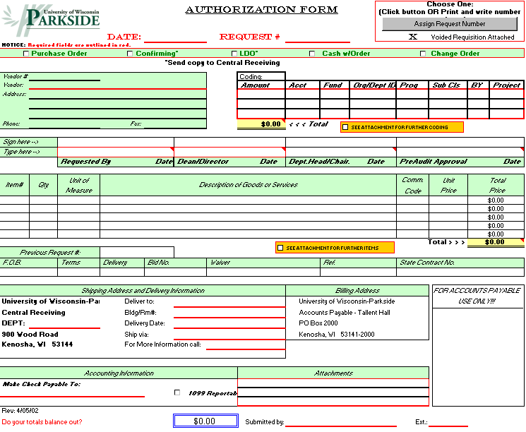
1
34
2
7
3

6

5
4

8

5
10
11
9
11
11
15

16

17

14

13

12
26
26
19

20

21

22

23

24

25

27
28
29

31
30

32
33
18

