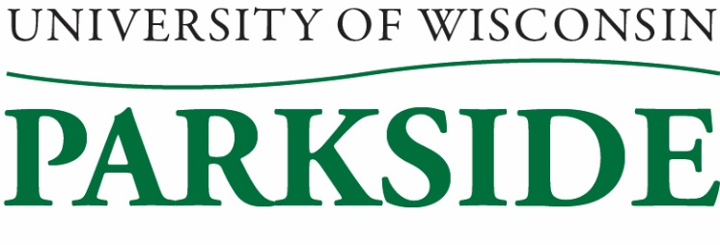

**University Staff Committee Meeting Minutes**

February 9, 2023 / 1:00 PM – 2:30 pm

Galbraith room

**Members Present**: **Katy Aiello,** **Sherry Craig*,* Jean Hrpcek, Carol Kinsley, Loki Lott, Michele Oakes-Cisler, April Puryear, Jenni Wagner**

**Members Absent: Heather Spencer**

**Guest:**

**Call to Order:**  12:59pm called to order by Sherry Craig

**Meeting Minutes Approval for January, 2023**

Michele Oakes-Cisler motioned to approve the minutes (with M drive added), Loki Lott seconded. Minutes approved.

**Extended Cabinet Update**

January Extended Cabinet – HLC presentations were wrapping up. Four people will be coming to campus on March 13-14 as part of the process. The new Physician’s Assistant program will need approval. The Sharing Shelves are being used. Enrollment was up in most categories - Spring enrollment was up 78 more than at the same time last year. HR is still working on the pay progression and promotion policies. Progression equates with salary range, promotion equates with different duties. Sheronda mentioned a lot of people are asking for raises, but some seem to be a bit high. Could be due to inflation as well as increased duties. Consensus in leadership is that you don’t get a promotion for doing more of a task. Sherry and Carol will ask Sheronda to send updates and/or the status of these policies for us to review at our March meeting.

January 31st – HLC was once again discussed – the submission was completed and turned in. The new course evaluation platform was presented. This should help ease the instructor evaluation process. Debra Karp talked about sexual harassment training, specifically for a certain student program. There were some enrollment and athletic updates given. The Big Idea contest was discussed and Black History Month events were presented.

**Shared Governance Update**

A Governance Charter for University Staff is being worked on. It is being pushed forward in order to include University Staff in the state statute. The University Staff Constitution is also being worked on. The website is being updated. Sherry will send out documents for us to review, with feedback due on February 24th.

ChatGPT AI browser is being used quite a bit. It seems to provide accurate and fast information. This has a lot of pros and it gets more intelligent as it gets used.

Campus updates included a lot of campuses having a hard time filing positions on University Staff committees/groups. It seems as if there are a lot of employee vacancies as well. Each campus apparently has different criteria in order to be eligible for the 2% raise.

President Rothman would like to increase enrollment by 10%. If we want employers to stay in Wisconsin we need to have educated residents to fill positions.

The results of the Free Speech survey were released.

**Upcoming Awards**

Regents Excellence Award – One individual and one program can be nominated from our campus. Nominations are due May 5th.

UWP Distinguished Service Award – Loki Lott and Jean Hrpcek volunteered to lead the committee. The timeline of this process needs to be verified.

**Professional Development Event**

The Professional Development event on January 19th had about 20 University Staff in attendance. It had favorable reviews. We wish more people would have taken advantage of it.

**Chancellor’s Search and Screen Committee**

We are allowed to nominate up to five University Staff employees for a possibility of filling a position on the Chancellor’s S&S Committee. An email will be sent out to gather nominees with a deadline of February 15th. Committee members are asked to reach out to possible candidates.

**New Business**

Ombudsman position for faculty has been created. We agreed it would be nice to have this for all staff.

Jenni Wagner, secretary, will not be here for the March meeting. We will need someone to fill in for the secretary position at that meeting.

It was expressed that it would be nice if the SAC offered a free membership. (Possibly even just during winterim and summer.) Carol Kinsley will talk to Dalinda Galaviz and the wellness committee to inquire about this. Simple perks, such as this, could help with employee appreciation.

**Adjournment:**

Motion to adjourn by Katy Aiello and seconded by Loki Lott.

Meeting adjourned: 2:07pm

Minutes submitted by: Jenni Wagner, Secretary