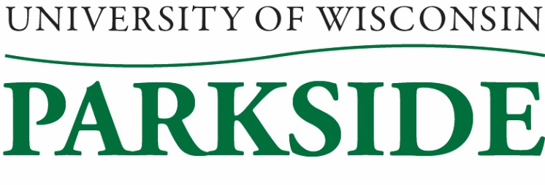
**DRAFT**

University Staff Committee Meeting Minutes
October 13, 2022 / 1:00 PM – 2:30 pm
Galbraith room

Members Present: Sherry Craig, Mary Henderson, Jean Hrpcek, Carol Kinsley, Loki Lott, Laura McClure, Michele Oakes-Cisler, April Puryear, Jenni Wagner, Heather Spencer
Members Absent: Bob Grieshaber

Call to Order: 1:01 pm by Sherry Craig

Meeting Minutes Approval for September 8, 2022
Laura McClure motioned to approve, Michele Oakes-Cisler seconded. Minutes approved.

Shared Governance Update
Carol and Sherry went to the governance orientation and shared governance meeting in Madison. Orientation just gave a brief explanation of what shared governance is - we should be part of policy decisions and discussions and we should have a voice.
Hoping to establish face to face meetings with President Rothman.
Looking into rebranding of University Staff, as it is sometimes confusing.
How does system view University Staff? Seems to be less and less of us. Campuses are to report how the numbers have changed over the past five years. Is System trying to replace University Staff with Academic Staff? Which positions would turn over once current staff leave?
Compensation of leadership - it is different at each campus.
Joint orientation session – met with two regents. Discussed funding issues. They are pushing for more money. Millions of dollars in deferred maintenance. Enrollment is low and continuing to decline. Biennial budget – increases in GPR. Asking for 4% and full funding.
Board of Regents – positive people advocating for students and employees. Governor Evers has appointed 7 regents which have not been approved, but they are serving.
Maybe students need to voice their concerns over the quality of education going down due to no tuition increases.
Campus updates – Madison has a new Chancellor. System employees are having remote work issues. Compiling ideas for non-monetary benefits. Changing everything from being under by-laws to both by-laws and procedures.
Joint shared governance session – increased mental health services for student to include: tele-counseling and psychiatry, Narcan rescue kits, mindfulness, and mental health screening for athletes.

UW Student Free Speech Survey
Very lengthy survey. Just want to gather information regarding how students feel about and understand free speech.

UW Strategic Framework
Meeting with President Rothman. A list with possible discussion points has been created. Voice any concerns to Sherry and Carol and they can relay them to President Rothman.

By-Law Review/Committee
It’s time to work on the By-Laws. Jenni Wagner will set up a meeting with Mary Henderson, Carol Kinsley, and Michele Oakes-Cisler.

Promotion/Reclassification Policy
Sherry and Carol will reach out to find out status. Sheronda should be invited to an upcoming meeting.

Emeritus
Sheronda provided Sherry with the policy stating that the University cannot give a privilege that staff cannot receive. Emeritus receiver should reach out to Human Resources for actual benefits.

SharePoint
M drive and the old SharePoint will be deactivated. Chris Almond is managing migration to the new system. The committee would like more information regarding this, as this was very concerning to almost everyone at the table, as we have heard very little about this and it affects us.

New Business
Sherry and Carol staffed a table at the benefits fair – some staff still don’t understand the difference.

Laura McClure – this is her last meeting as her new position is Academic Staff. Sherry will reach out to Katy Aiello to see if she would like to fill the vacant position. (She was next in line from the election.)

Mary Henderson - will be working M-Th year-round (83%), so she will now be able to attend summer meetings.

Flu shots on campus – November 1st. Sign up in My Portal.

Brief discussion on new COST HR process. (Again – helpful to have Sheronda at an upcoming meeting.)

Adjournment:
Jean Hrpcek motioned to adjourn, Carol Kinsley seconded. Meeting adjourned.

Minutes submitted by: Jenni Wagner, Secretary

