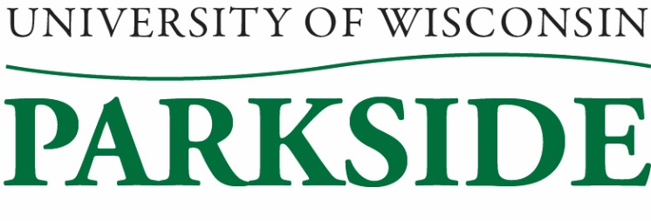
**DRAFT**

University Staff Committee Meeting Minutes
December 8, 2022 / 1:00 PM – 2:30 pm
Galbraith room

Members Present: Katy Aiello, Sherry Craig, Loki Lott, Michele Oakes-Cisler, April Puryear, Jenni Wagner, Heather Spencer
Members Absent: Mary Henderson, Jean Hrpcek, Carol Kinsley

Guest: Sheronda Glass

Call to Order: 1:02pm by Sherry Craig

Meeting Minutes Approval for November 10, 2022
Loki Lott motioned to approve, April Puryear seconded. Minutes approved.

HR Update
Associate Vice Chancellor Glass attended the meeting. She was presented with a list of questions/concerns before the meeting. The majority of the discussion was around the Promotion/Reclassification and Progression Policies, as well as the Human Resources department.

The Promotion/Reclassification policy is still a work in progress. No new updates have happened to the policy, as she is still waiting to hear from the Academic Staff Committee. The Progression Policy was on hold because campus was waiting for guidance from System. However, System has decided against providing any guidance, as there’s too many differences between the campuses. Sheronda hopes to have both policies competed by the upcoming fiscal year. The Progression Policy will hopefully help with the compression created by having to hire new staff at levels close to or over current employees.

President Rothman has presented his strategic plan, with two key components being growing enrollment and employee compensation.

Major changes coming with the implementation of ATP/Workday. Staffing will be looked at to determine what we do and how it will be handled with the new system.

Human Resources and Business Services have been aligning with the changes with the implementation of the COST program.

Just because COST and Shared Services are major parts of HR, you can still reach out to any HR staff with your questions.

Biennial budget proposal is 4 + 4, but that is only possible if the state fully covers it.

Shared Governance Update
Most campuses reported that they are working on the pay progression policy, that they are having staffing issues, and that they are working on employee climate surveys.

The joint session reported that the current regent appointees are still awaiting approval. A standardization of how policies are created is being worked on.

Faculty Senate Update
Carol was supposed to report on this, however she was unable to attend our meeting. The big takeaway from this meeting was making sure everyone had completed their mandatory training.

Holiday Tree
The tree was set-up and decorated. A small handful of staff helped decorate the tree on Thursday, December 1. It was a bit disappointing that more staff (not just university staff) did not stop by to help. Take down is tentatively scheduled for Friday, January 6.

Stipends
April submitted the paperwork for the Governance Board stipends. Jenni noted that the committee does have the responsibility and right to approve the payments.

By-Law Review/Committee
Mary Henderson, Carol Kinsley, Michele Oakes-Cisler, and Jenni Wagner have been reviewing the By-Laws. Jenni went over the changes to the current draft. The Committee will need to reconvene to cover the Amendment section. Hoping to be able to vote on this next month.

Professional Development Training/Luncheon
The menu is being worked on. The speaker has been contacted. A Qualtrics survey is going to be sent out.

New Business
Mary Henderson is no longer a University Staff employee, so she has vacated her position on the committee.

Adjournment:
Katy Aiello motioned to adjourn, Heather Spencer seconded.
Meeting adjourned: 2:19pm

Minutes submitted by: Jenni Wagner, Secretary

