University of Wisconsin – Parkside
TAM User Guide

Search & Screen Committee Members

Content

Logging in………………………………………………………………3

View Applicant Data…………………………………………………...5

TAM – Logging In
- Go to https://uwservice.wisc.edu/tam/login You may want to add this link to your favorites.
- Log into TAM using your campus username and password. Choose “UW-Parkside “and enter your login credentials like you are logging into your computer.

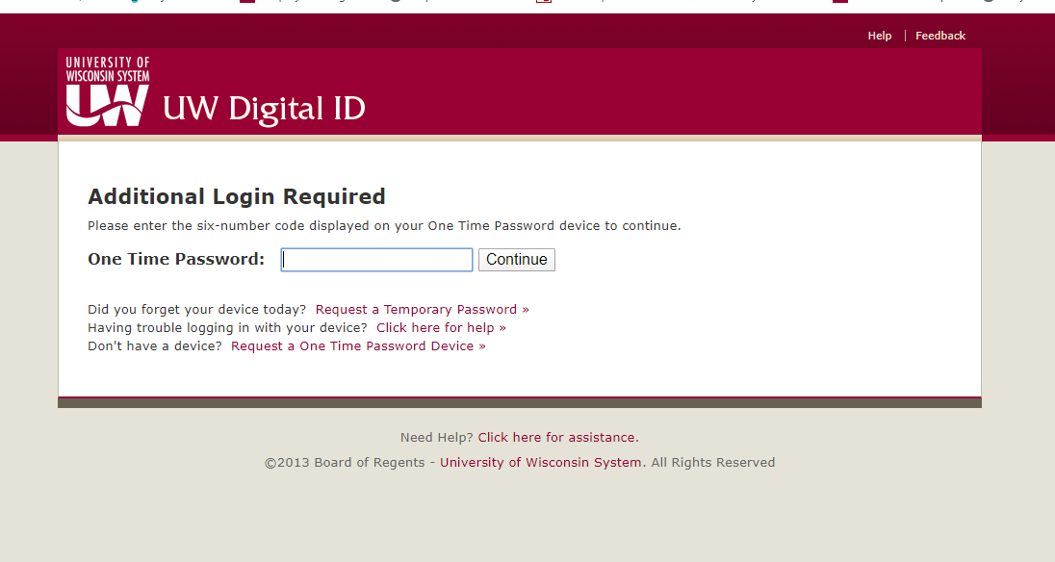
- Click on Recruiting on the navigation bar on the left and then Click on Browse Job Openings.

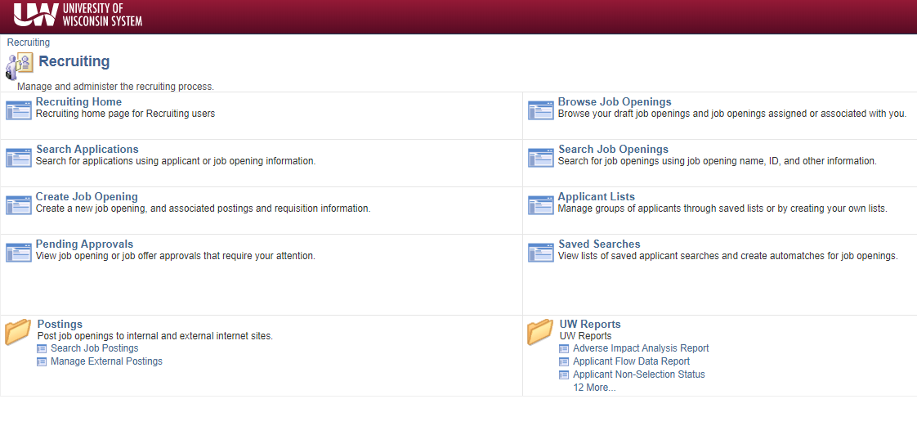
3. The job openings you are assigned to should be listed.

- Click on the name of the recruitment.

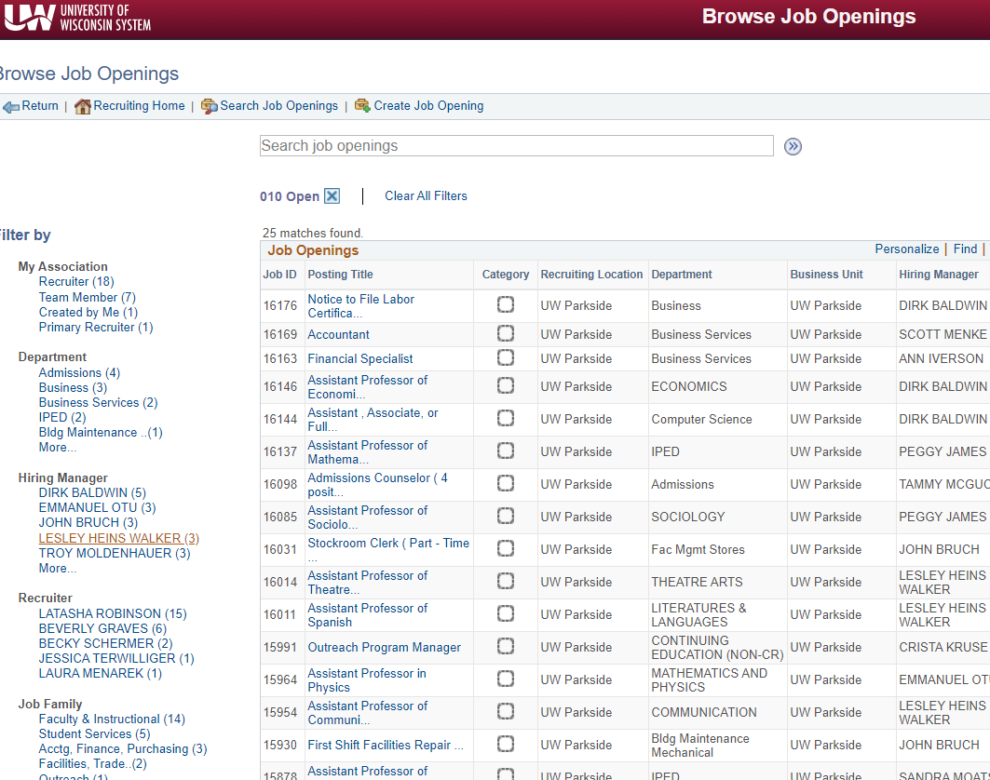
5. To view applicants resumes or CV’s only click the resume icon. 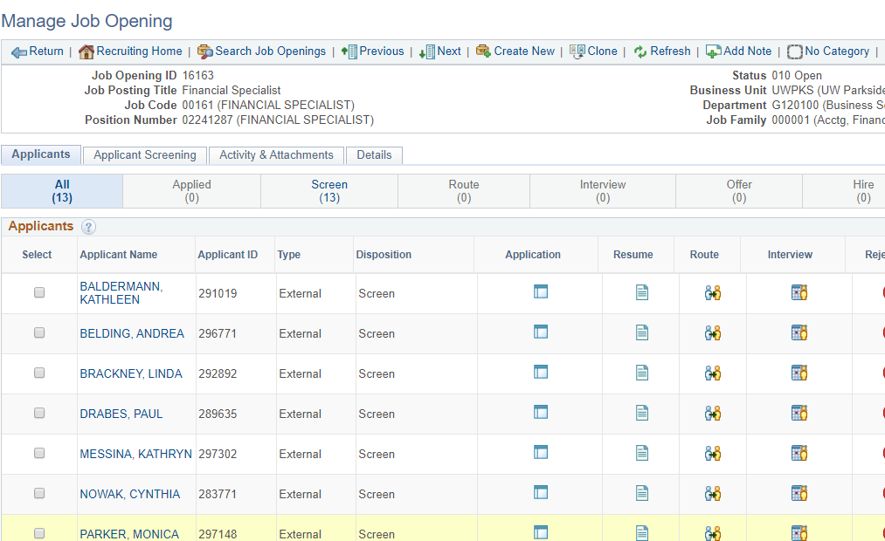
Applicant Name
Applicant Name
Applicant Name
Applicant Name
Applicant Name
Applicant Name
Applicant Name
6. To view all application materials for a candidate click Application icon.
Applicant Name
Applicant Name
Applicant Name
Applicant Name
Applicant Name
Applicant Name
Applicant Name
7. Download all applicants materials to a SharePoint site. Share this site will all Search & Screen Committee Members
8. Select “Return” to go back to the list of applicants and view another candidates application materials.

Name

