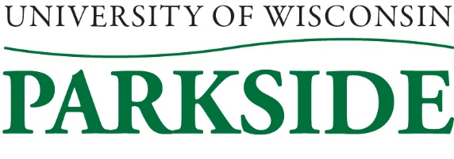

University of Wisconsin System’s Compensation: Merit Pay

We are adopting the University of Wisconsin System’s Merit Pay policy. Being familiar with our policy and procedure will help you in understanding information with regard to extraordinary salaries that fall outside of a given range.

Read Our Policy and Procedure

Click the links below and read the entire policy and procedure.

SYS 1277.B. Compensation: Merit Pay

https://www.wisconsin.edu/uw-policies/uw-system-administrative-policies/compensation-2/compensation-merit-pay/

Effective Date: July 1, 2015
Last Updated: December 2019

