Intermittent Furlough: Monthly Timesheet Entry (to be completed by employee and/or supervisor)

Timesheet entry is required to decrease monthly salary. It is suggested that you submit your entries once the Furlough leave is approved by your supervisor, ahead of time. For your salary to be reduced by unpaid furlough taken during the month, all furlough leave (and hours worked) must be reported and approved before the payroll confirms each month. Any furlough leave approved after the monthly payroll has processed will be reduced from your next month’s check.

Full Day – FURLM

Regular hours worked (FUREG) must be entered on the timesheet for the week in which Furlough is taken – tracking purposes only. For FTE’s less than 100%, please be sure that your weekly hours total matches actual FTE. All payable time should be approved by the supervisor using the MSS Dashboard under Payable Time Need Approval section.

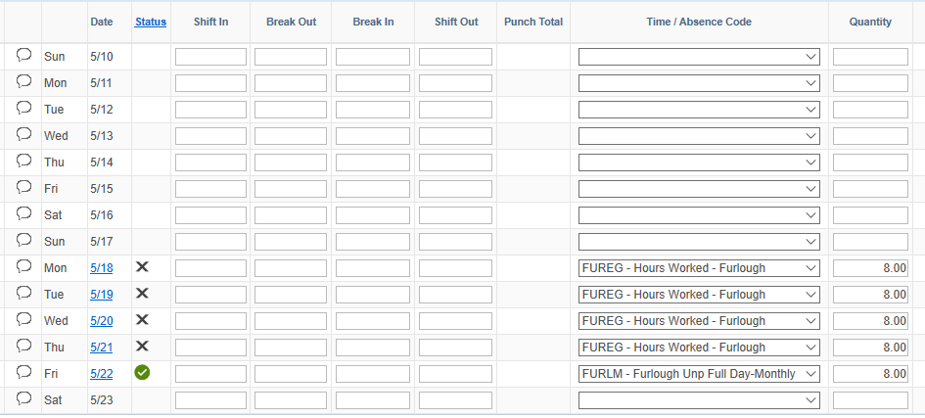

Employees will receive legal holiday pay if they are in pay status the day before or after the legal holiday. Leave Accruals will remain whole. The Furlough Timesheet entries do not count towards your monthly leave reporting requirements. Please be sure to also submit any leave taken using the normal process and/or report No Leave Taken by the 5th of the following month.

Consecutive Furlough: Monthly Timesheet Entry (to be completed by Campus HR/UWSS Payroll)

Timesheet entry is required to decrease monthly salary. All employees on Consecutive Furlough will have all entries uploaded on their behalf ahead of time. All FURLM – Full Day Furlough Unpaid time will be approved by Campus HR and/or UWSS Payroll.

Regular hours worked (FUREG) will be entered on the timesheet for any consecutive days that end mid-week – tracking purposes only.

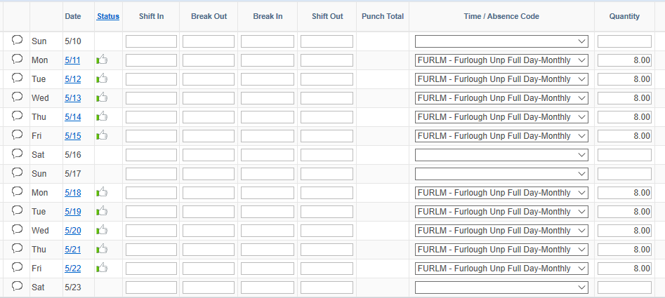

Employees will not receive legal holiday pay for any fixed legal holiday. Employees will accrue floating legal holiday at original FTE (i.e. for 7/4/20). Leave Accruals will remain whole. The Furlough Timesheet entries do not count towards your monthly leave reporting requirements. Please be sure to also submit any leave taken using the normal process and/or report No Leave Taken by the 5th of the following month.

Temporary Work Reduction (TWR) Furlough: Monthly Timesheet Entry (to be completed by employee and/or supervisor)

Timesheet entry is required using FUREG – Furlough Hours Worked for employees to report time worked for the entire duration of the Temporary Work Reduction (TWR) based on the reduced FTE, for tracking purposes. If you are also required to take unpaid Furlough time in addition to your reduced hours, you will then use the Intermittent Furlough entry instructions.

Example below is for a TWR to 50% FTE reporting 20.00 hours per week. Since 5/25/20 is a paid holiday, the leave entry satisfies the reporting requirement and only the remaining 12.00 hours need to be reported.

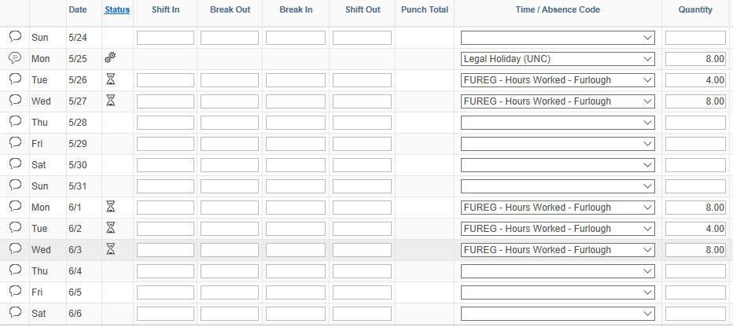

Employee will be paid legal holiday based on their original FTE. FUREG hours reported may have to be reduced in week of legal holiday so employee does not exceed their scheduled hours. Leave Accrual balances will be increased to match their original FTE accrual for the duration of the furlough. The Furlough Timesheet entries do not count towards your monthly leave reporting requirements. Please be sure to also submit any leave taken using the normal process and/or report No Leave Taken by the 5th of the following month.

Compensation Reduction Percent Smoothing Furlough: Monthly Timesheet Entry (to be completed by employee and/or supervisor)

Timesheet entry is required to track Furlough Absence used (COVID Furlough) and Furlough Time Worked (FUREG).

Regular hours worked (FUREG) must be entered on the timesheet for the week in which COVID Furlough is taken – tracking purposes only. For FTE’s less than 100%, please be sure that your weekly hours total matches actual FTE (80% = 6.40 hours per day). All payable time should be approved by the supervisor using the MSS Dashboard under Payable Time Need Approval section.



Employees will receive legal holiday pay if they are in pay status the day before or after the legal holiday. Leave Accruals will remain whole. The Furlough Timesheet entries do not count towards your monthly leave reporting requirements. Please be sure to also submit any leave taken using the normal process and/or report No Leave Taken by the 5th of the following month.