

**New Learner Registration**

Step 1: Create an account

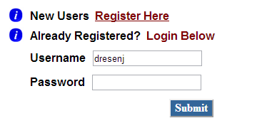

Select University of Wisconsin-Parkside form the drop-down menu

Step 2: Select your institution (then, proceed to steps 2-7)

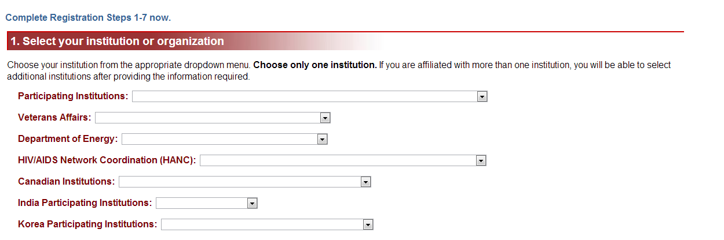

Step 3: Once you are logged in, you will be directed to the Main Menu. Scroll down to “add a course”

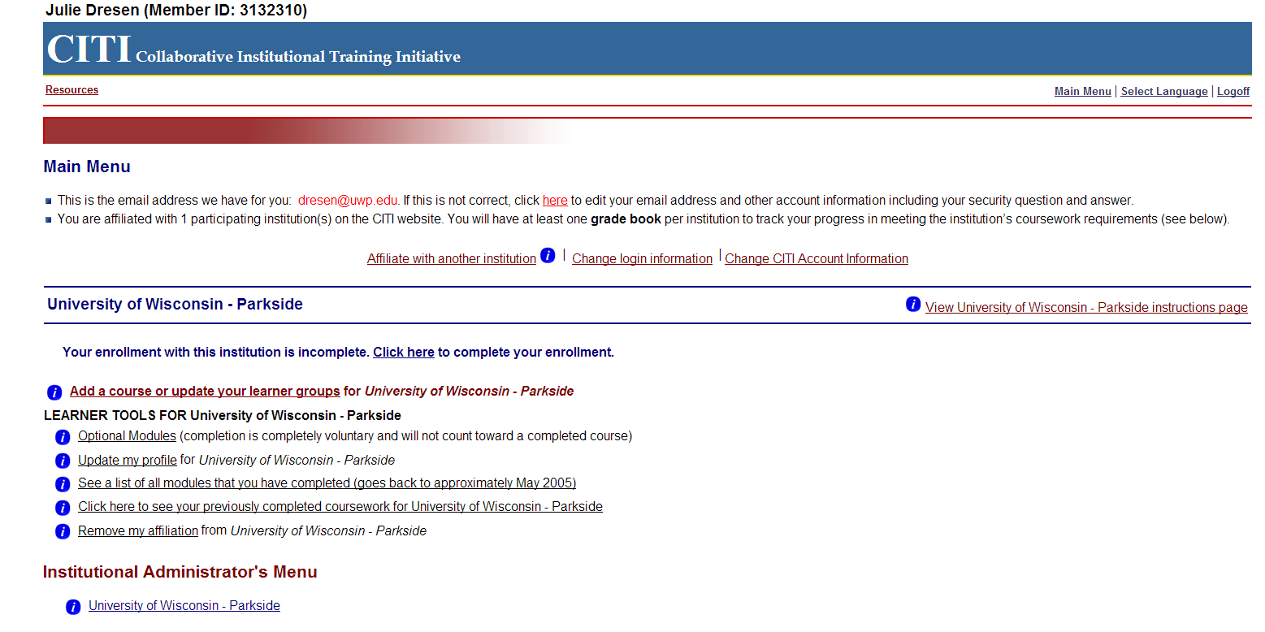

Step 4: Next, select “Faculty, staff, and students – Basic/Refresher” or “IRB Members – Basic/Refresher”

