Workday Spend Authorization Faculty FAQ Guide for CRCA Grant Applications

Step-by-Step: Create and Complete a Spend Authorization
1) Access your Spend tools
- From the Workday home page, click the search bar and type “My spend authorization”. Choose My Spend Authorizations.
- In My Spend Authorizations, review your existing items or click Create Spend Authorization to start a new one.

2) Fill in the header (Spend Authorization Information)
- Start Date / End Date – Enter actual trip/event dates (these may default to today and must be corrected).
- Description – Include event name and location (e.g., “HLC Annual Conference – Chicago, IL”) to prevent returns for missing location.
- Business Purpose – Select the appropriate option (e.g., Conference, Meeting, Training) from the dropdown/prompt.
- Reimbursement Payment Type – Leave the default unless your unit instructs otherwise.
- Justification – Provide a concise rationale (presenting, mission-critical information, compliance/professional requirement). Some institutions require answering prompts (destination, itinerary, funding source, etc.).

3) Add estimated expense lines (Spend Authorization Lines)
- Click Add to create a line for every anticipated cost (airfare, lodging, per diem/meals, registration, mileage, ground transport). For each line, complete:
  - Expense Item (searchable list), Quantity, Per Unit Amount; Total Amount calculates automatically.
  - Memo (optional) for context (airline name, nightly rate, # of nights, mileage rationale).
  - Budget Date – usually leave as default.

4) Apply the correct Worktags (funding & classification)
- Use the Worktag prompt (three-dot/ellipsis “twinkies”) to search and select the Driver Worktag (e.g., Grant, Project, Gift, or Cost Center). Only one driver worktag is typically used; Workday then auto-populates Related Worktags (Fund, Function, etc.).
- Confirm the full set on the line or header: Program, Grant, Project, Gift, Cost Center, Fund, Function, plus any Additional Worktags (e.g., Location).
  - If you are planning on submitting a request for funding from CRCA, FASPOF, or ASPDF, you should still input your department’s Cost Center information. CRCA, FASPOF, or ASPDF Worktag information should only entered once you have completed your trip and you are requesting reimbursement. The Spend Authorization functions as a way for the aforementioned committees to review your application, and so technically, at the point of completing the Spend Authorization, you have not received approval from a funding committee.

5) Attach required documents
- Go to the Attachments tab and upload supporting documentation (agenda, estimates, approval emails), per your unit policy.

6) Submit and track approvals
- Click Submit. The Spend Authorization routes automatically for review/approval based on the worktags:
  - Cost Center Manager/Secondary CCM
  - Grant → PI or Award Billing Specialist; Project → Project Manager; EAP → EAP Partner (where applicable)
- Use the item’s Process/History view to see where it is in the workflow and who the approvers are.

7) View or download a PDF copy
- From My Spend Authorizations, open the specific authorization. Click the PDF icon in the upper-right to generate and download the PDF.
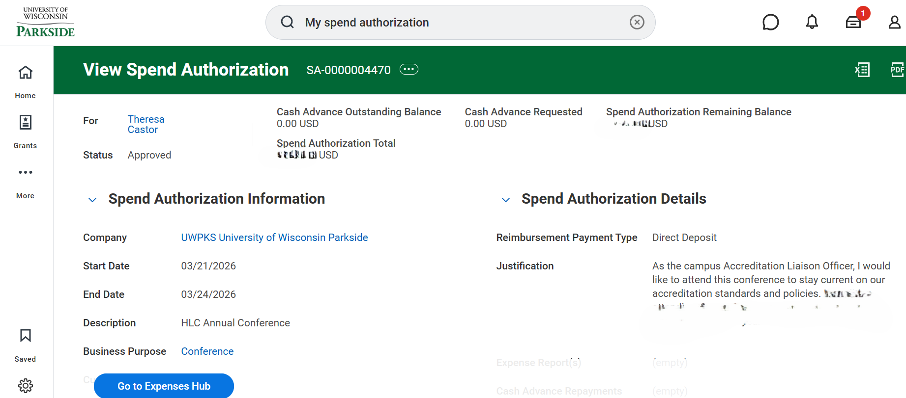

8) After your travel
- Create an Expense Report and reference the approved Spend Authorization to itemize actual costs for reimbursement.
- When you complete your Spend Authorization, you may enter the funding codes from CRCA, FASPOF, and/or ASPDF in the Programs worktag area to attribute costs from specific items to the appropriate funding source.
- Keep track of your math to ensure that you are requesting funding up to the approved amount from a funding committee.

How to Find the Correct Worktag
Use the Worktag prompt to search for Program, Grant, Project, Gift, Cost Center, Fund, and Function Worktags. Once you click to Add an expense item, a window will open up with additional information, including Worktag details, for you to enter.
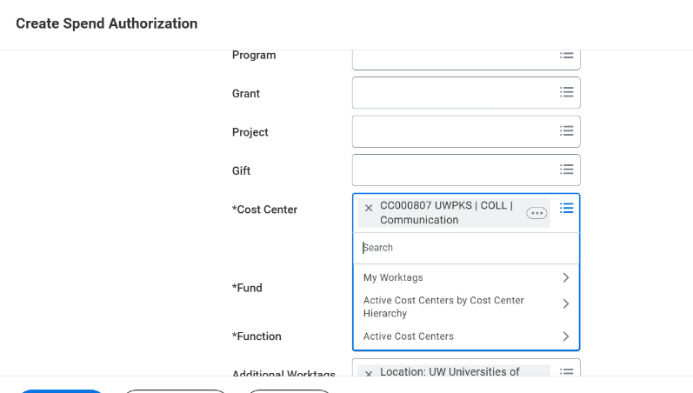

Accessing Your “My Spend Authorizations”
Use the search bar to locate My Spend Authorizations. From there, you will be able to see all of your Spend Authorizations and their status.

Opening and Reviewing a Spend Authorization
Open the authorization to review details or download PDF.

Additional Resources
Create a Spend Authorization (from UW Knowledge Base)
Create an Expense Report (from UW Knowledge Base)
Additional Travel Authorization Guidance for Frequently Asked Questions

