 | Senior Vice President for Administration  1730 Van Hise Hall  1220 Linden Drive  Madison, Wisconsin 53706  608.262-4048 Fax: 608.262.3985  email: srvpadm@uwsa.edu  www.uwsa.edu/srvpadm/index.htm

Date: May 20, 2002

To: Chancellors
Vice Chancellors
From: David Olien, Senior Vice President 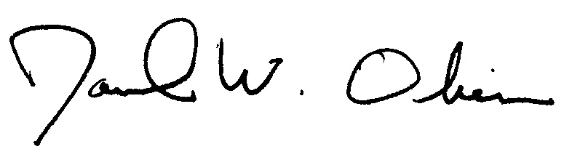
Administration

Re: 15 Passenger Vans

You are all aware of the recent publicity surrounding the risks of 15 passenger vans.
We started reviewing this situation when the National Highway Traffic Safety Administration (NHTSA) issued a national warning advising, “The risk of a rollover crash is greatly increased when 10 or more people ride in a 15 passenger van”.
In March the NHTSA reissued their warning on 15 passenger vans further reinforcing the risks associated with these vehicles (Attached).

We are sensitive to the fact that many campus departments and programs rely on these vans for their transportation needs. These vans are used for athletic activities, instructional field trips and student organization events. Most activities result in the safe transport of students, faculty and staff.

There are no simple or inexpensive solutions to resolve the problem of 15-passenger van usage. Suggestions include: increased driver training, limiting the number of passengers, restricting cargo, removing seats, installing a third axle, etc. We are reviewing all of these options and will continue to work with all of our institutions and the Department of Administration to minimize risks associated with 15 passenger vans as we look for safer alternatives.

The safety of our students, faculty and staff must be our number one priority. While we continue to evaluate and study this issue, the following interim measures should be taken effective July 1, 2002 to minimize the potential of a more serious situation:

- An immediate ban of all student drivers of 15 passenger vans with the exception of students over the age of 25 that meet all System driving requirements and complete required training for operating 15 passenger vans.
- An immediate ban of all towing with 15 passenger vans regardless of the driver.
- An immediate ban of any car top carriers with 15 passenger vans
- A block on leasing of 15 passenger vans through current State and University contracts unless reviewed and approved by the institution’s risk management office. (Under no circumstances will students be allowed to lease or drive 15 passenger vans)
- 15 passenger vans can be used to transport cargo if the cargo and passengers are restricted in size and weight and number to the manufacturer’s suggested rated capacity of the vehicle.
- UW System faculty and staff will be allowed to continue driving 15 passenger vans as long as they meet System driving requirements and complete required training for operating 15 passenger vans and meet a minimum age requirement of 25.
- Exception to the Interim Policy may be permitted until such time as a permanent System policy is issued. Any such exceptions must be made in writing by the chancellor of each System institution, with the concurrence of the System Risk Office.

System staff is participating with State Risk Management and Transportation Services staff in a joint meeting with the three major manufacturers of 15 passenger vans to investigate safe, cost effective alternatives to 15 passenger vans. To facilitate consistency and adequacy of current training programs, I am directing the System Office of Safety and Loss Prevention to review all institutions’ 15-passenger van training programs. Each campus should send their current 15-passenger van-training curriculum to Sheri Ackley who will coordinate this review in conjunction with the institution Risk Managers.

These interim policies were discussed with the Chief Business Officers during their teleconference on May 17, 2002 and met with no immediate opposition. I have included the topic of 15-passenger vans on the Administrative Staff agenda for May 23, 2002.

Finally, all passengers and drivers must be reminded of the law requiring seat belt use and common sense must prevail when planning trips to avoid driver fatigue. Should you have any questions, please contact Sheri Ackley at (608)265-5383.

cc: CBOs
Institution Risk Managers

Attachment

