SCIENCE NIGHT
A College of Natural and Health Sciences Seminar Series
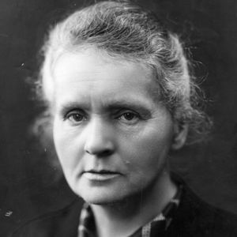
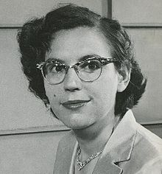
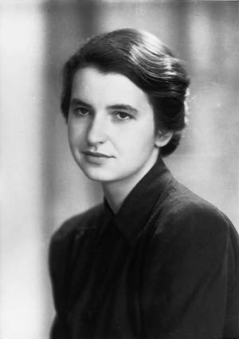
SHE BLINDED ME WITH SCIENCE!

Women who have rocked our science world
Dr. Summer Ostrowski will take you on a journey exploring the role of women in the history of science. She will highlight some well-known and not-so-well-known women who have made significant (but sometimes overlooked) contributions to the Science, Technology, Engineering, and Mathematics (STEM) fields.

Dr. Ostrowski has a passion for science and teaching. Her research in vertebrate paleontology has taken her all over the world, but her primary interests involve fossil fishes from “The Age of Dinosaurs”. She teaches Human Anatomy and Physiology at University of Wisconsin – Parkside. Summer has been involved in Women in Science events for most of her career, including events at Michigan State University and the Kenosha Public Museum.
Wednesday, November 12, 2014
7:00 – 8:00 p.m. in the Union Cinema

Free parking after 6:30 p.m. - Everyone is invited - refreshments provided

