Are College Students Vaccine Hesitant?
By: Abigail Suter and Bridget Stella
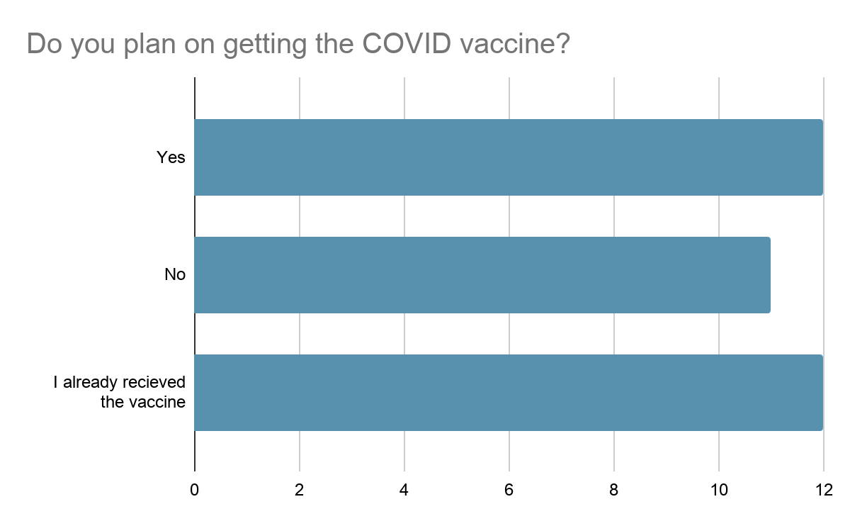
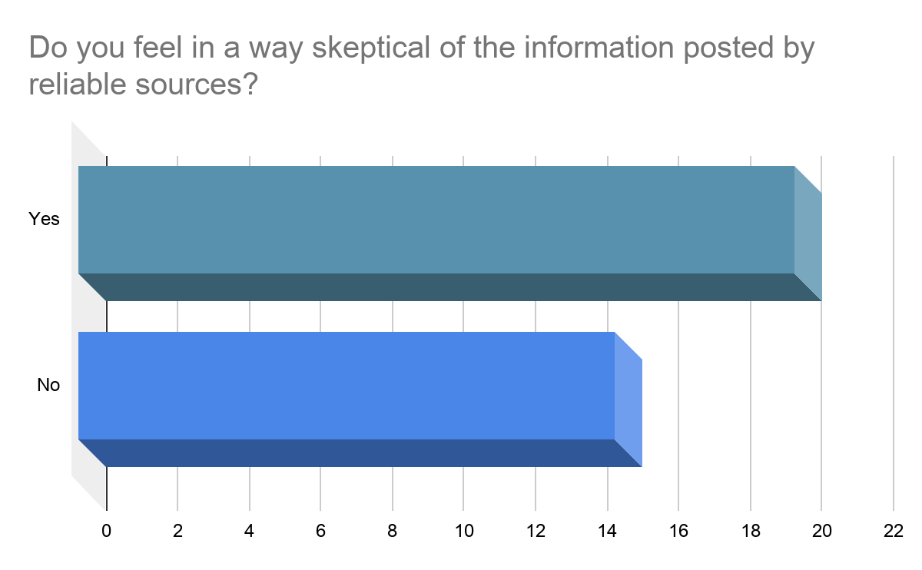
From March 21, 2021- April 3, 2021, we created a survey targeted towards the age group of 18-29, in hopes of investigating their conceptions surrounding the COVID vaccine. Our survey received 35 responses with the majority being female (30 responses), and only five were male. This survey was to get a glimpse of perceptions surrounding COVID vaccines, and isn’t representative of the “college student” population. There are limitations to the generalizations that you could make in terms of the results of this survey including the lack of diversity and response bias. Because our survey was only open for a short amount of time, we did not get a diverse group of respondents like we had hoped. The race and/or ethnic identity of respondents were as follows: 27 Caucasian, 4 Latino/a, 2 Multi-racial, 1 African American and 1 Asian American. The results that we gained from this survey only let us see vaccine conceptions through one lens, but this lets us obtain data and opinions from real members of our target audience.
Our participants were given 11 questions to answer anonymously. We also discovered that many have already received the vaccine, and know many others who have gotten vaccinated as well. The questions all focused on important factors in regards to the COVID-19 vaccines. For example question ten asked “Do you feel in a way skeptical of the information posted by reliable sources?” Out of the 35, the majority (57%) answered yes, (43%) no. Even with being skeptical towards the vaccine, out of the 35 respondents, 12 are planning on getting their vaccination, 11 will not be receiving a vaccine, and the other 12 have actually been vaccinated. Overall, 80% of the participants agreed that reaching herd immunity is important for the community.
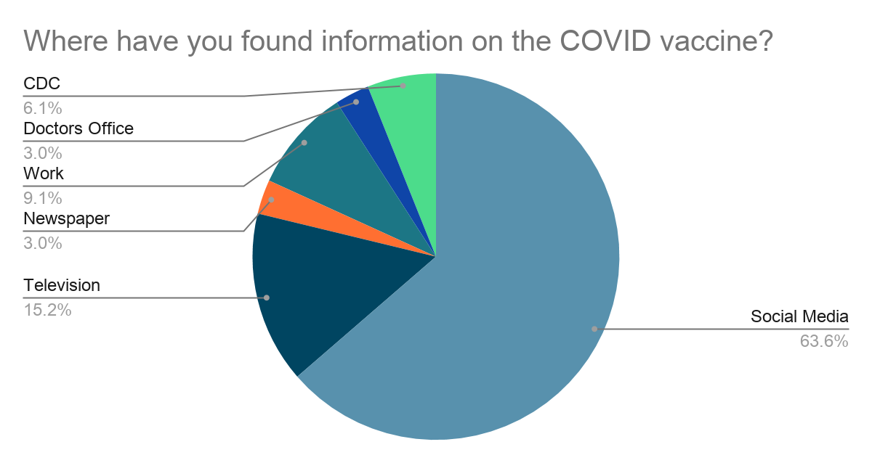
Important take-aways that we got from this survey is that a lot of college students get their information from social media and television. Although information that they receive may seem reliable, college students feel skeptical about the information surrounding the COVID vaccine. They also feel that there isn’t a lot of research and hard facts surrounding the COVID vaccine which may lead to some feeling uneasy about getting the COVID vaccine.
One way that we suggest to overcome this hesitancy is to face it head on, and to not shy away from information that may be daunting. Knowledge is power, and gathering information to help you get a better understanding of the COVID vaccine may put yourself at ease a little more. It’s also important to branch out of the “norm” and research outside of just social media to help paint a better picture of what the vaccine is all about. Also, having open and honest conversations with those around you so that you can have a discussion about your health and others health as well! Your health matters, and the health of your loved ones matters! If you have concerns about the vaccine, this is totally natural! I know throughout our educational journey, we are taught to question even things that are seen as facts. On the flip side, the magnitude of this pandemic also puts the importance of the vaccine into perspective. So when thinking about whether or not you should get the vaccine you should do some research, talk with those who are close to you, and ultimately you will have to make a decision!

