Post 1:
Graphic:
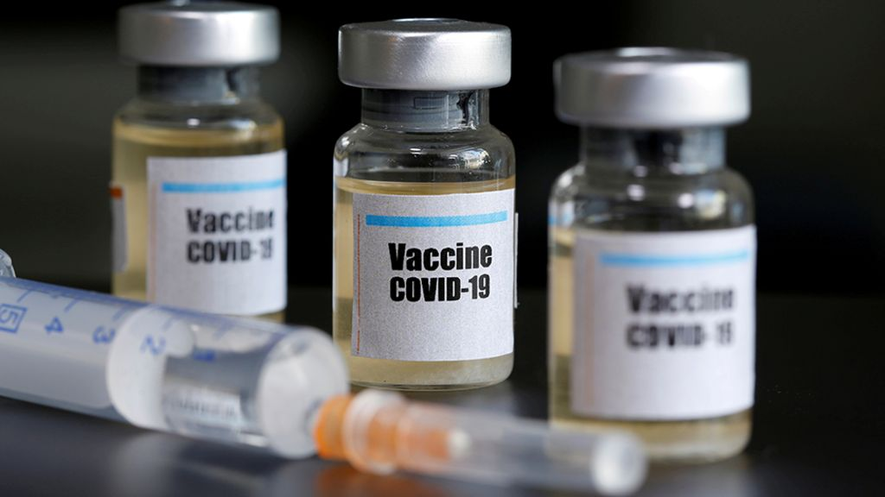
Content:
Many people seem to be concerned about how the new COVID-19 vaccines could impact their health. Some people feel like there is not much information on these new vaccines, so they aren’t sure about how “safe” it really is. It turns out that there actually is a great deal of information on the new vaccines, you just have to know where to look. Here is a link that is a good starting spot when making the decision of whether or not to get vaccinated! https://www.cdc.gov/coronavirus/2019-ncov/vaccines/safety/safety-of-vaccines.html

Post 2:
Graphic:
Content:
While vaccines are being produced quickly, they are also being produced effectively and cautiously. Safety comes first, and being vaccinated has many benefits. Some of these benefits include being able to see other people more as well as protecting the people around you who are at high risk of catching COVID-19. You can read plenty of other benefits and reasons to get vaccinated here:
https://www.cdc.gov/coronavirus/2019-ncov/vaccines/vaccine-benefits.html

