Post 1:
Graphic:
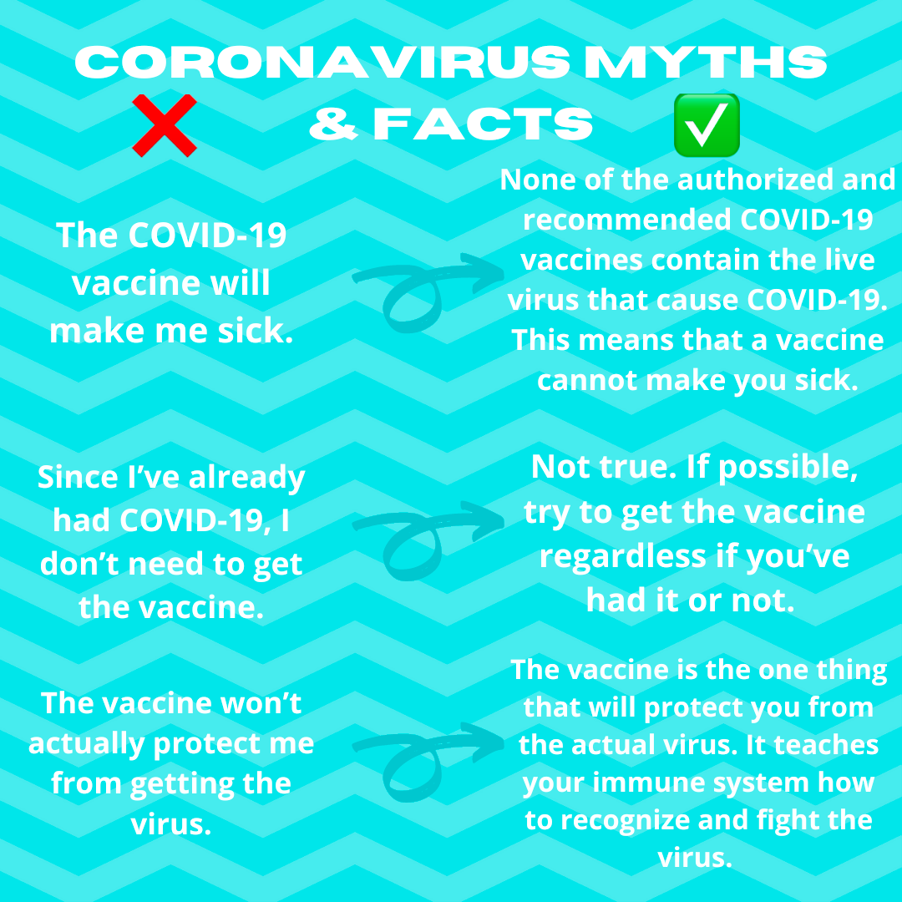

Content:Check out some #Coronavirus myths & facts. Check out the CDC link below to see some more myths & facts regarding COVID-19 and the vaccine. #factsweshouldknow #COVID19
https://www.cdc.gov/coronavirus/2019-ncov/vaccines/facts.html

Post 2:
Graphic:
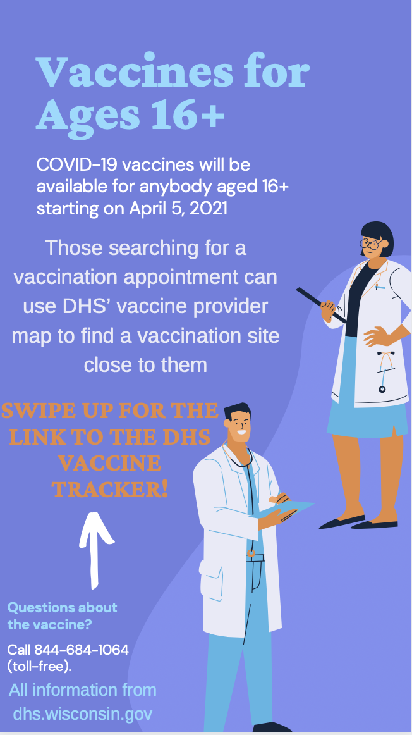

Content:
This is a sample Instagram story using information regarding the eligibility of people aged 16+ for the COVID-19 vaccine.
Link to the DHS Vaccine tracker: https://www.dhs.wisconsin.gov/covid-19/vaccine-map.htm

