Post 1:
Graphic:
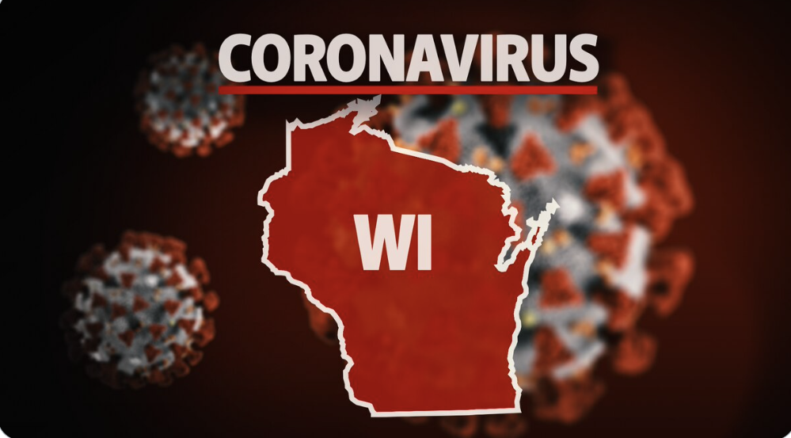
Content:
Our goal is to curb the spread of COVID-19 by reaching 75% herd immunity in Kenosha County. Visit this website to learn more about when you will be eligible to do your part and receive your vaccine! https://kenosha-county-covid-19-response-kenoshacounty.hub.arcgis.com
Post 2:
Graphic:
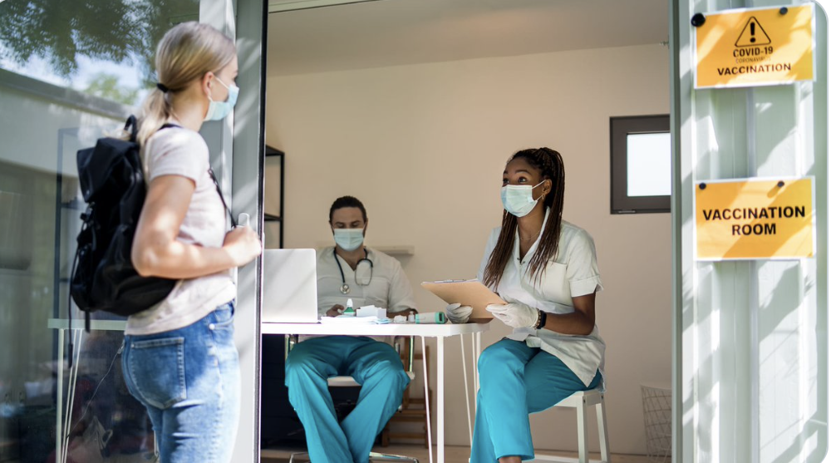
Content:
Now that there are vaccines for COVID-19 rolling out, people are wondering how they can get theirs. Click this link from the CDC to get more information on how to get vaccinated!
https://www.cdc.gov/coronavirus/2019-ncov/vaccines/How-Do-I-Get-a-COVID-19-Vaccine.html

