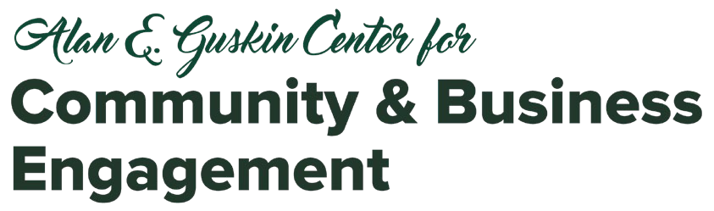

Onboarding Liability and CBL

Questions to discuss with your community partner | Related Forms
Do your students need a background check done? If yes:  - Who pays? ($10 if done through UW-Parkside Police)  - To whom are results sent?  Be aware that background check forms can take up to one week to be processed. | UW-Parkside Formal Criminal Background Check Form  Questions:  Molly Beecher  UW-Parkside Police & Public Safety  (262) 595-2455  beecher@uwp.edu
Does the partner agency have other required paperwork (e.g. confidentiality forms, volunteer application, etc.?)  - Do forms need to be completed before service begins?  - To whom should students turn in their paperwork? | Varies for each agency
How will students be trained and/or given an orientation? | Expectations can be articulated and included in the CBL Partnership Agreement Form  Safety & Empowerment for Experiential Education training module is available through Canvas
How will students be supervised on site? | Expectations should be included in the  CBL Partnership Agreement Form
In addition, you should consider issues related to students’ transportation to the site:
- If you are taking the class as a group to the community partner’s site, you should consider having students complete the UW-Parkside Field Trip Waiver Form.

- Transportation Options
  - Student provides/finds own transportation (can include Uber/Lyft)
  - Rental of a van through UW System vendor (for whole class field trips)
In most cases, the University does not require a student driver authorization for CBL activities since it’s part of the requirement for coursework or graduation.
Please consult with Parkside’s Safety-Risk Management Office about any questions or concerns, especially if your CBL course includes activities that you think may entail risk.
Alysse Hargrove, University of Wisconsin-Parkside Safety-Risk Management Email: hargrove@uwp.edu Phone: 262.595.3493

uwp.edu/cbe Updated 10.23.25

