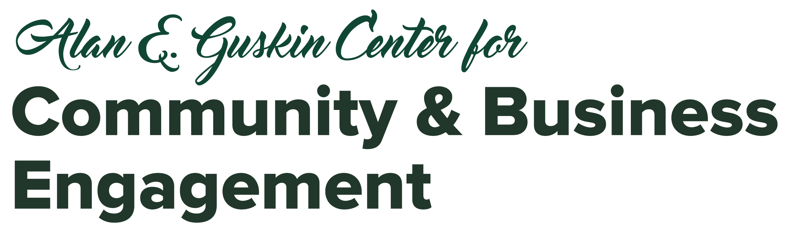

Community-Based Learning (CBL) Learning Goals (Revised 2023)
A designated CBL Course must include the Community Engagement learning goal along with at least one additional goal.

1. COMMUNITY ENGAGEMENT | Learning to use knowledge and skills to make useful contributions to the community (REQUIRED)
At the 100-level: Students will identify individual ways to contribute to a community and demonstrate the ability to work actively within community contexts and structures.
At the 200-400 level: Students will also work collaboratively with others in the community to achieve a public good.

2. ACCOUNTABILITY | Understanding what a responsible choice is and that one’s present education and lifelong learning is a personal responsibility
At the 100-level: Instructors should address one expectation from section A “Responsible Choice” plus a minimum of one other component from each of sections B and C.
At the 200-400 level: Instructors should address one expectation from section A “Responsible Choice” plus a minimum of three other components from sections B and C, choosing at least one from each section.
Criteria addressed should be identified on the syllabus. Responsible choice assumes that all required work is completed with evaluation based on the listed components.

A. RESPONSIBLE CHOICE
- Identifies opportunities to expand knowledge, skills, and abilities as part of completing required work.
- Identifies multiple approaches for solving the problem. Approaches may be elementary in scope.
- Conducts an introductory evaluation of solutions including: history, logic, reasoning, feasibility and impact. Introductory implies that key elements of depth may be missing.
- Implements the solution in a manner that addresses the problem statement but may ignore relevant contextual factors.

B. CONNECTS TO DISCIPLINE AND EXPERIENCE
- Applies previous knowledge and skills to demonstrate comprehension and performance in novel situations.
- Compares life experience and academic knowledge to infer differences, as well as similarities, and acknowledges perspectives other than own.
- Uses skills, abilities, theories, or methodologies gained in one situation in a new situation to contribute to understanding of problems or issues.

C. REFLECTION AND SELF-ASSESSMENT
- Evaluates prior learning (past experiences inside and outside of the classroom) with some depth, revealing slightly clarified meanings or indicating a somewhat broader perspective about educational or life events.
- Articulates strengths and challenges (within specific performances or events) to increase effectiveness in different contexts (through increased self-awareness).
- Evaluates results relative to the problem defined with some consideration of need for further work.

3. SOCIAL JUSTICE | Understanding and questioning values and beliefs about diversity and inequity within social, political, economic and historical contexts
At the 100-level: Instructors should address a minimum of 2 of the learning outcomes.
At the 200-400 level: Instructors should address a minimum of 3 of the learning outcomes from at least two categories.
Criteria addressed should be identified on the syllabus and guidelines for respectful academic interaction in the classroom should be established.

A. KNOWLEDGE
- Identifies privilege (dominant culture, effects on others, etc.) and its relationship to social justice issues in community life, politics, and government.
- Expresses how their own attitudes and beliefs differ from those of other cultures.
- Compares and contrasts various values and beliefs in the context of historical and geopolitical events.
- Examines identity and race as a social and cultural construct from multiple perspectives with a focus on self-awareness.

B. SKILLS
- Examines research on race and culture.
- Analyzes social justice from the perspectives of human rights, dignity and freedom.

C. DEVELOPMENT OF ATTITUDES
- Recognizes how personal agency and individuals can impact social change through organized and personal activism.
- Demonstrates the ability to collaboratively work in community contexts and structures.

4. GLOBAL PERSPECTIVE | Applying knowledge and skills to respond to global issues in local and international contexts
At the 100-level: Instructors should address a minimum of 2 of the learning outcomes.
At the 200-400 level: Instructors should address a minimum of 3 of the learning outcomes from at least two categories.
Criteria addressed should be identified on the syllabus.

A. KNOWLEDGE
- Identifies major global concepts, issues, processes, and systems.
- Recognizes that their culture is one of many diverse cultures and that alternate perceptions and behaviors may be based in cultural differences.
- Explains how human actions modify physical environments and vice versa.

B. SKILLS
  - Demonstrates empathy and tolerance for ambiguity in a global context.
  - Collects valid and reliable data and information on international issues.
  - Applies strategies to work effectively with those who are from other cultures and places.
  - Uses knowledge of diverse cultural frames of reference and alternate perspectives for problem-solving.

C. DEVELOPMENT OF ATTITUDES
- Expresses openness to most, if not all, interactions with culturally different others.
- Recognizes interconnected nature of the world and the importance of global citizenship.
- Identifies positive aspects of different cultures from around the globe.
- Reflects on how their national and cultural identities have been shaped.

